Winter Fun,
by Petrica Lorena, VI

Here is my snowman
Big and round,
Sitting on the
Cold, cold ground.
Here is my snowman
Big and fat,
He has a carrot nose,
And he wears a funny hat!

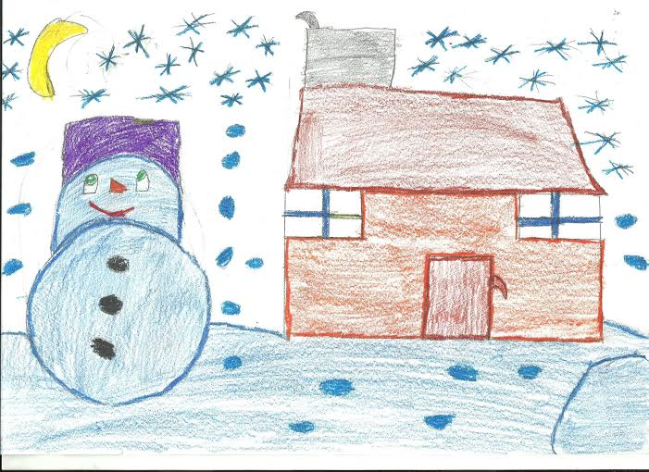

Balogh Rebeka IV

Created by the pupils of
IOAN SLAVICI Elementary School, Oradea

Snow...,
by Bucsa Andrei, VI

Snow is Perfect
Snow is Bright
But most of all,
Snow is Delight.
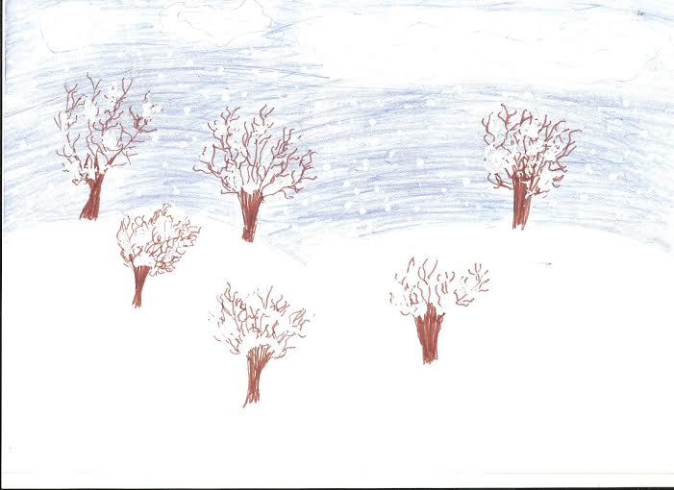

Dani Alexia IV

Winter Night,
by Sarca Petrisor, VI

The snow comes down
In the dark of night.
When we awake
The world is ALL white.
Holding hands out in the snow
Slowly on our way we go.

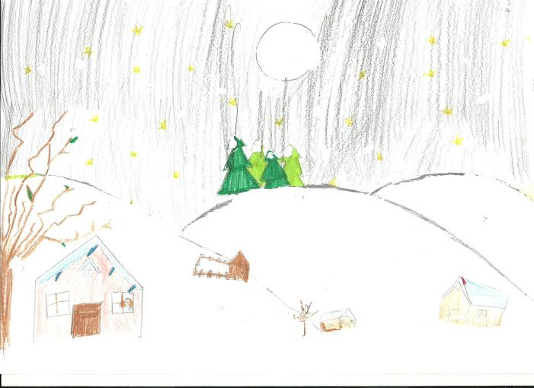

Diana Galca IV

