Snowflakes,
by Nica Alin, VI

Snowflakes snowflakes
Dance all around
Snowflakes, snowflakes
Touch the ground
Snowflakes snowflakes
In the air
Snowflakes snowflakes
Everywhere!
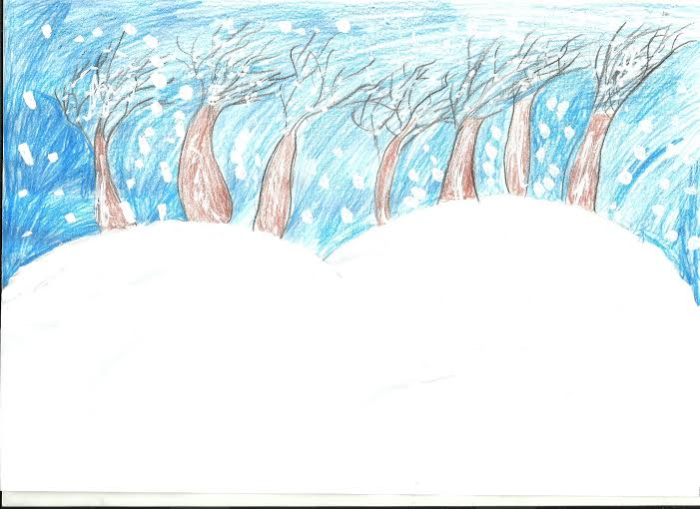

Caldarar Marius Alexandru IV

Created by the pupils of
IOAN SLAVICI Elementary School, Oradea

Snowman,
by Dobai Marta, VI

Once I was a snowball,
Then I grew and grew
Now I am a snowman
How do you do?

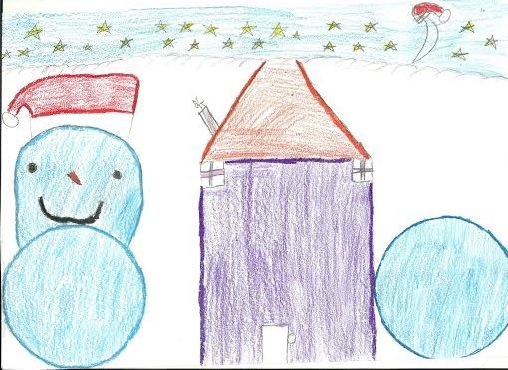

Barburas Alexandra IV

Winter Wonderland by
Sarca Petrisor, VI

Winter Wonderland
Ice is slippery
Nothing is hot
The weather is cold
Everything you touch is cold
Really cold

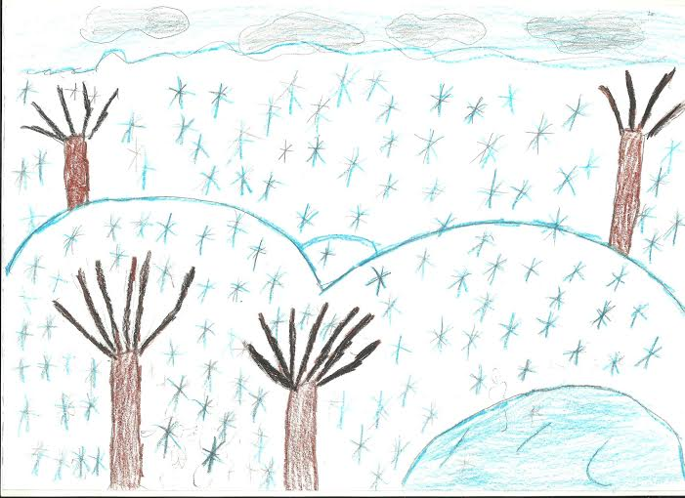

Trok Rebeka II

