THE SHIPWRECK

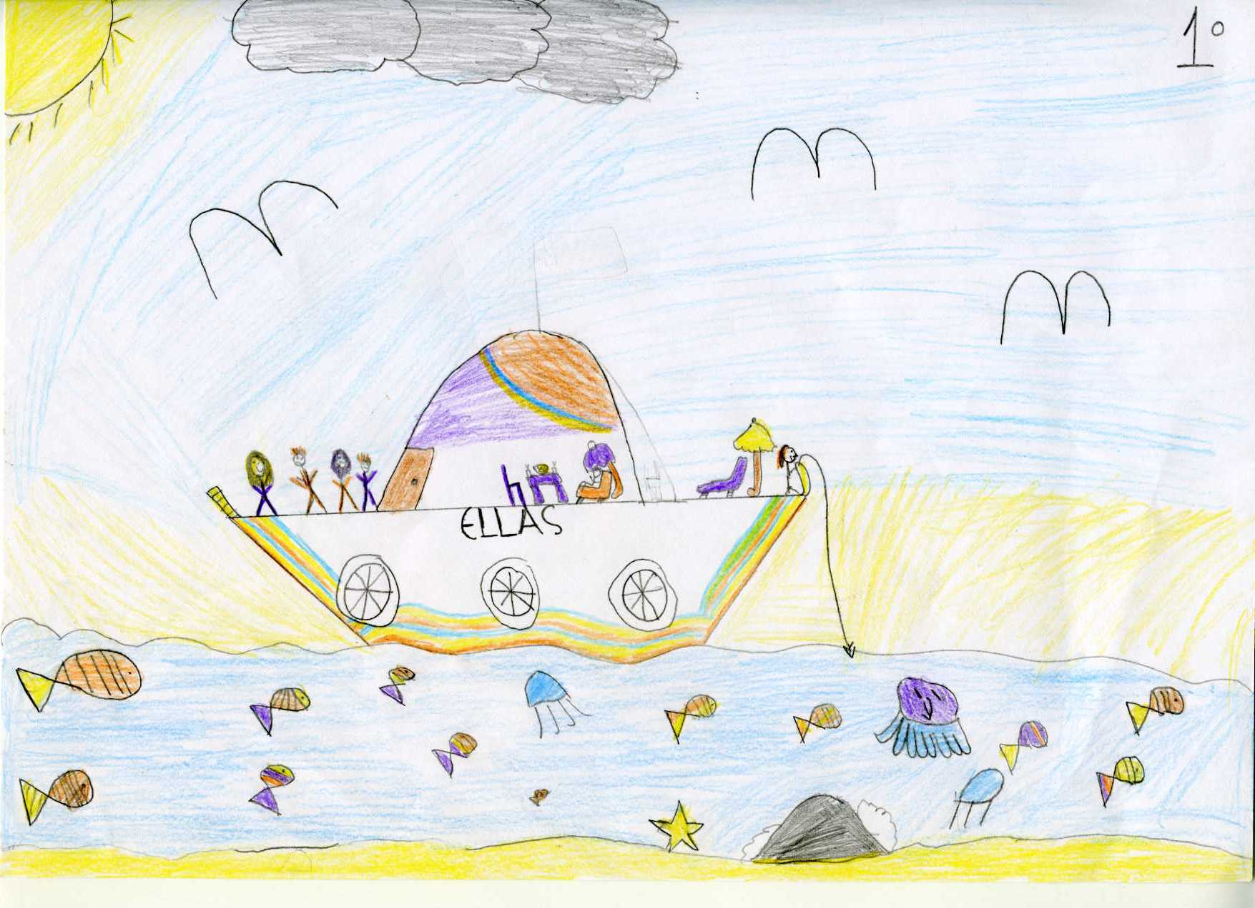

ERAS: I am Eras! I am 13 years old. My family and I decided to go on a 10day cruise.

MUS: I am Mus, an 11 years old girl.

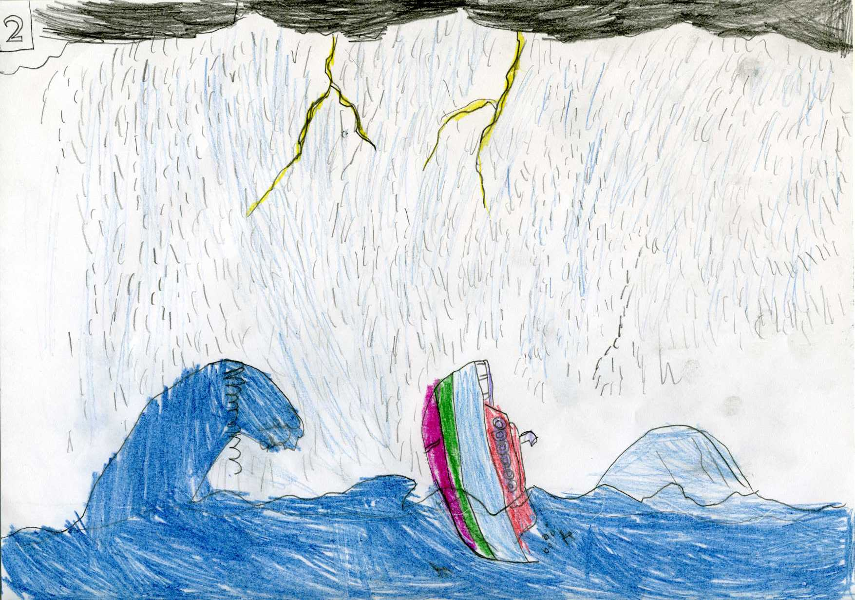

On the third day of vacation, and while everything was going well, suddenly a huge storm was created while the family where sleeping. The boat rose and fell with great force and leaned one right and one left. The captain announced: “All passengers have to put lifejackets on and board the lifeboat”! Indeed, some boarded but those who did not manage to board remained in the sea swimming and fighting with huge waves.

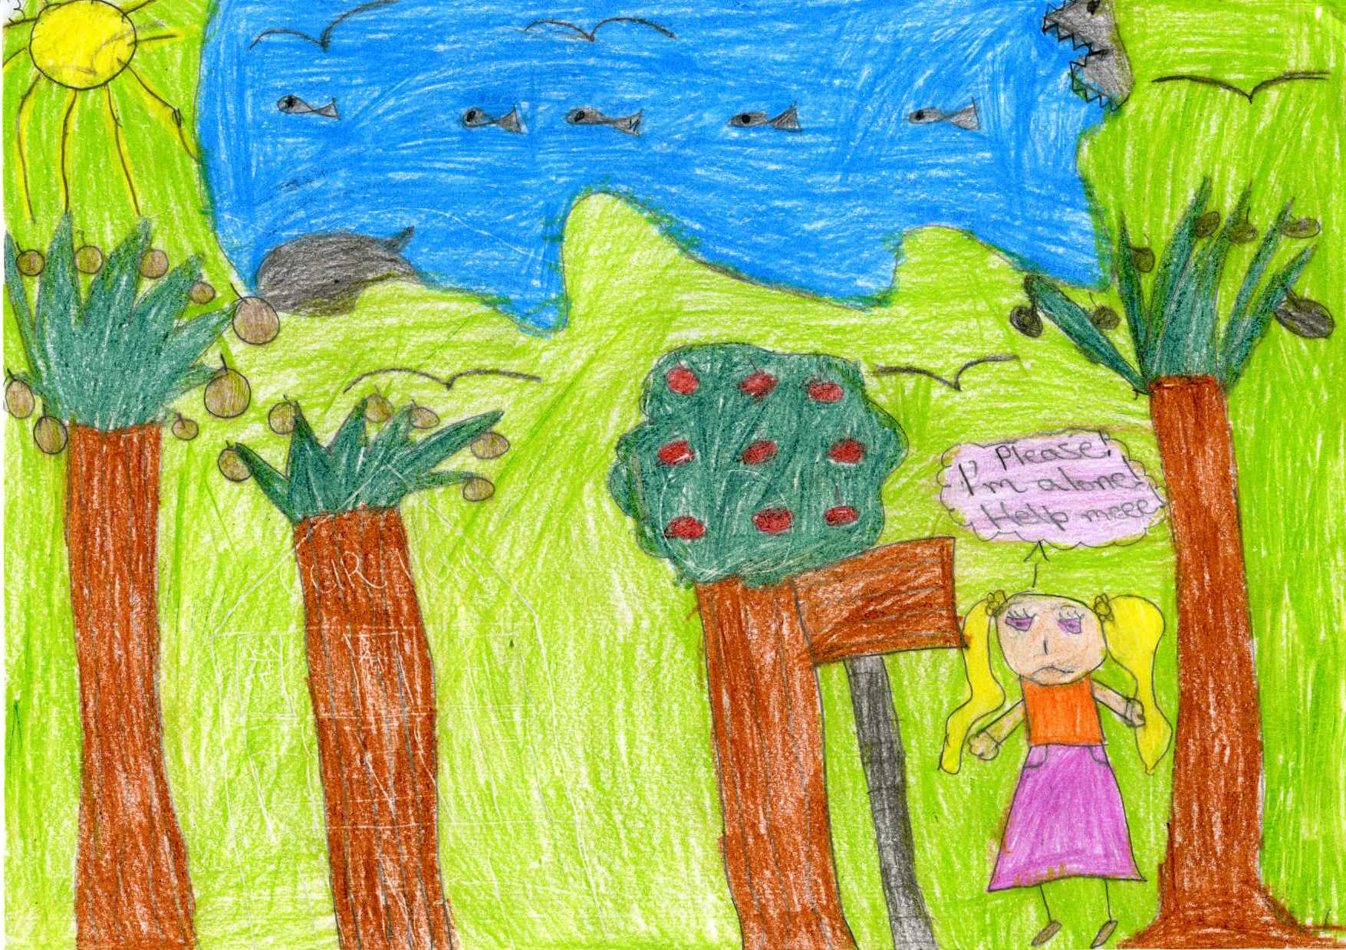

MUS: I began to tire by swimming and at dawn I was found lying unconscious on the beach of an uninhabited island.Once the sunlight started, I woke up, looked right and left and started getting terrified and praying for help. Then, I realised that I had lost my family. I went to the beach looking for them desperatelly. It was then that I found my brother Eras injured and unconscious lying on the sand. I threw some water on his face and managed to revive him.

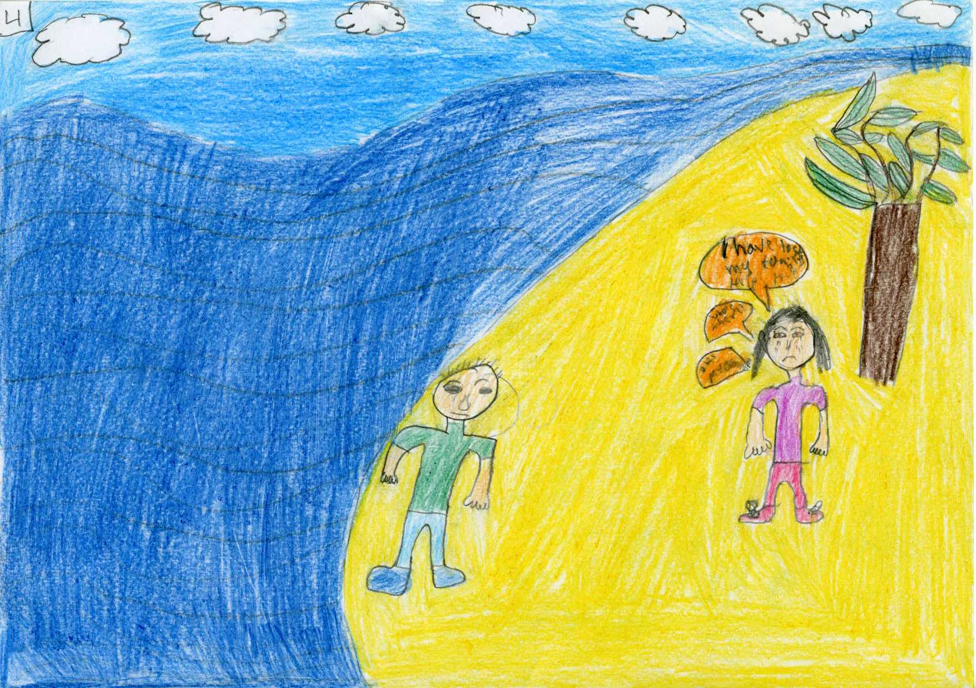

ERAS: After we met we began to think how we would overcome our difficulties and survive. Our first aim was to find drinking water. So we started looking all over the island.
MUS: After walking for a long time we suddenly heard a noise resembling a creek. For our good fortune, it was actually a water spring. The first aim was achieved.
ERAS: Our second thought was about how to find food. The options were minimal: fruits from the trees or fishing.

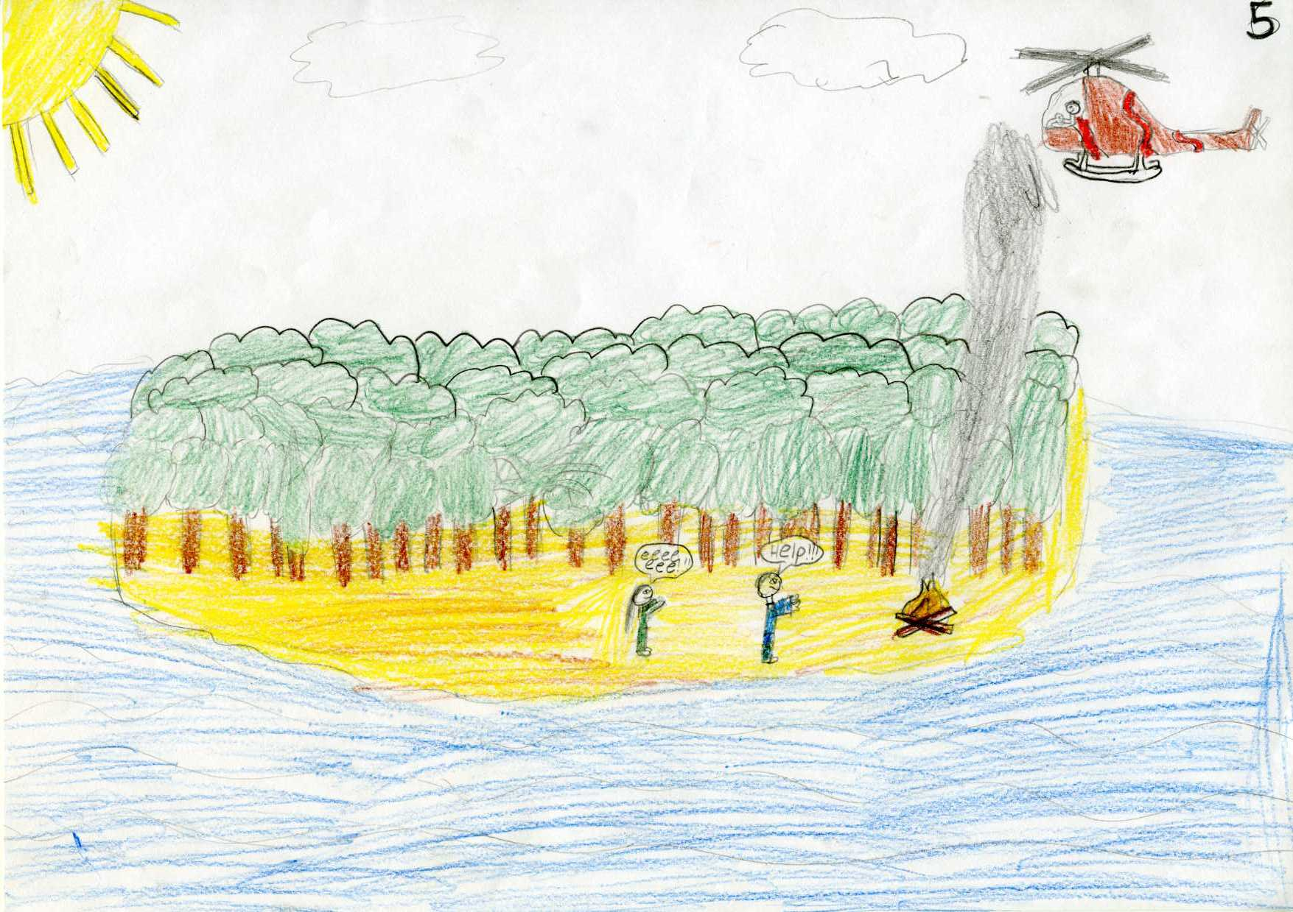

MUS: As days passed, our food lessened and our body began to give out. As a deux ex machina a helicopter surrounded the island and waving our hands the pilot fortunately spotted us.

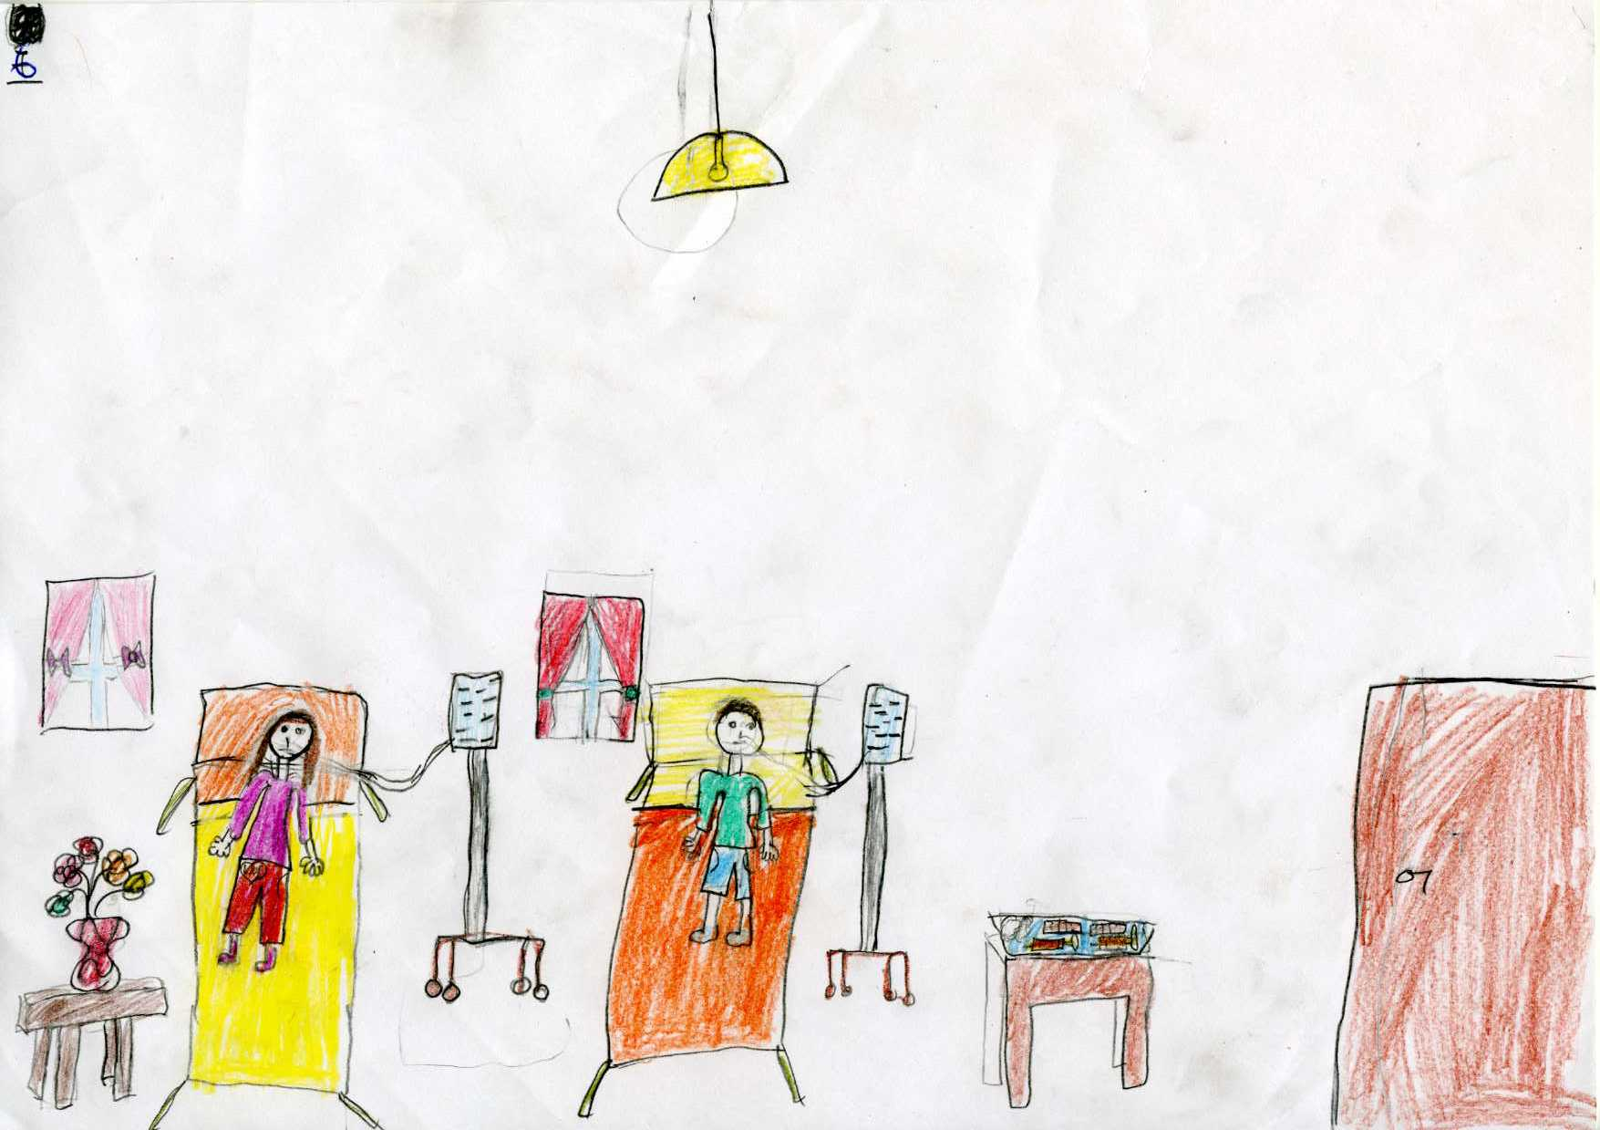

ERAS: After giving water and and food to us, they transported us to the hospital.

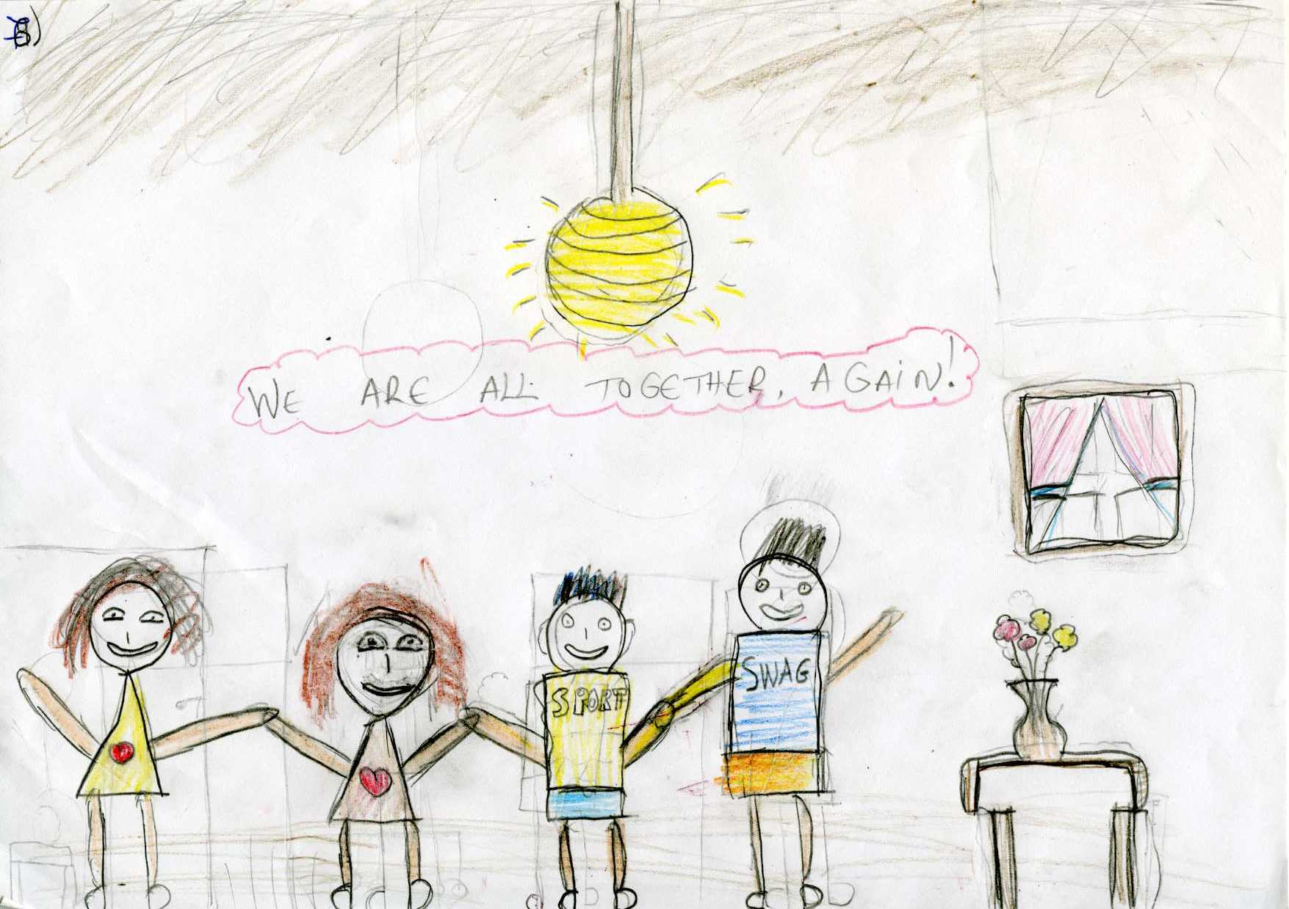

MUS: Our parents that had been saved too and called to come and pick us, were thanking God that saved all of us from this great adventure.

