Adventures in the Amazon

The Eras-boy is an American 12 year old teenager who is forced to leave behind him the luxury of living for an expedition in the Amazon with his grandmother Kate Cold, a journalist who has undertaken to write an article regarding a unknown and strange creature the beast, as they call it. The day they departed, heading to the airport, Eras-boy had very distressed feelings, because he would leave his friends behind and the comforts of city living. During the flight Eras-boy was trying to get used to the idea, what the life in the Amazon would be like. For endless hours they kept seeing beneath an area of forests, all the same green that crosses rivers, like slid over the gleaming snakes - and the most impressive of all had milky brown color. When the plane landed in Santa Maria de la Luz, Kate informed her grandson that they would climb from the Rio Negro to the Upper Orinoco, an almost unexplored triangle, where they assumed that there would come the beast. Shortly later they met with other members of the mission of International Geographic.
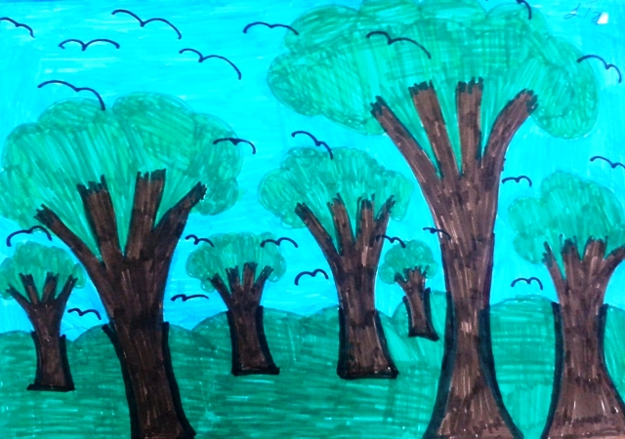
For the young American, who had come out of the country just to know Italy, the homeland of his mother's ancestors was amazing the difference between the wealth of some and the extreme poverty in particular, all mixed up. The landless peasants and unemployed workers were arriving in groups looking for new horizons, but really end up living in shacks, without money and hope. That day was a feast and the population was wandering cheerfully, as in carnival: orchestras of musicians were wandering in the streets, people were dancing and drinking, many were disguised. They stayed in a modern hotel but could not sleep from the noise of the music of fireworks and firecrackers.
The group of the International Geographic ascended the Rio Negro, the Black River. The boat was quite large with an old noisy engine smoking and a makeshift plastic roof to protect travelers from the sun and rain that fell like a warm shower several times every day. The starting part of their journey from the Rio Negro turned out to be an exercise for their patience. They progressed as turtles and as the sun was falling they had to stop, not to be hit by logs drifted with the flow. Sometimes there where the river looked clean and calm, benefiting go fishing or swim for a while.
On the pier of Santa Maria de la Luz awaited them a tall man, with a sharp bird profile, intensely masculine characteristics and pleasant expression with skin tanned from the countryside and with a black mane tied to tail at the nape. “Welcome. I am César Santos and this is my daughter, Mus-girl” he introduced himself. Eras-boy calculated that the girl had the age of his sister, twelve to thirteen years old. He had curly messed hair, faded by the sun, ash eyes and skin.
Before landing, the two children, Eras-boy and Mus-girl, talking to each other realized that they have enough common interests and thus created together a good friendship. When they settled in the hotel, the César Santos began to settle luggage mission and plan the remaining trip with the journalist Kate Cold. Meanwhile Mus-girl invited , Eras-boy to move about the surroundings. "After sundown do not go outside the boundaries of the village, it is dangerous," warned the César Santos.
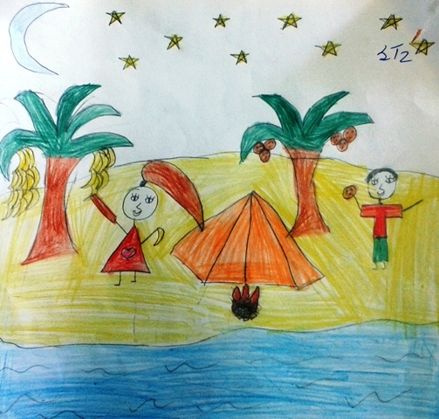
On their way to the village they had the feeling that they were being watched by thousands of eyes behind the thick and lush vegetation of the Amazon. They entered a few meters in the dense jungle and stayed silent. As if trying to look Eras-boy has not found anything among the trees, the natives were hiding in their environment. Suddenly he felt hands gripping him firmly by the arms and turning saw that Mus-girl and he were surrounded. The natives did not remain at a distance, now Eras-boy could feel the sugary smell of their bodies. He noticed that they were short and thin, but now could be sure they were very strong. A hand closed his mouth and before he realized what was happening, he felt himself lifted into the air caught by the feet and hands. He felt a hit to the head, did not know if it was with fists or with a stone, but he realized that it would be better to let them carry him otherwise they would eventually stun or kill him.
The kidnappers went running and by any step his body rattled wildly, the pain in his shoulders was as if his uproot hands. It seemed that they did a great route until finally they stopped and let him fall on the ground. When his eyes became accustomed to the pale moonlight, he saw that he was the middle of the forest, lying on a bed of leaves that covered the ground. Around him, in close circle, he felt the presence of native, though he could not see with so little light and without his glasses.
One of the natives in the darkness seemed more puny, more old man and stood out because he wore a crown of feathers, unique gem in the nude body, started a great debate. Mus-girl understood the meaning, because she knew the languages of indigenous and although people of fog had their own dialect, many words were similar.
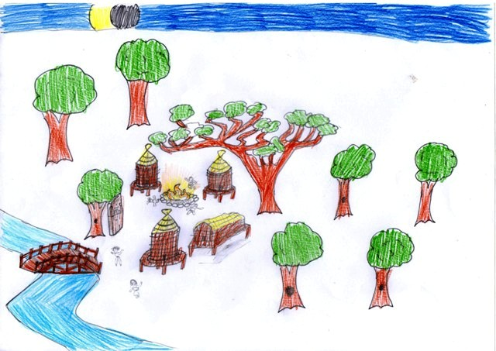
The following night, natives held a great feast in honor of their leader Taha. This was his chance Eras-boy and Mus-girl escape. In the hut where was Eras-boy and Mus-girl tied, Eras-boy remembered that he had a penknife with him. So he tried to catch the knife out of the pocket of his trousers to cut the ropes and managed to escape. Eventually the children were able to cut the ropes. Upon leaving the hut, they run silently not to be perceived from the natives.
In the end, the children arrived at the hotel where all they waited anxiously. Also Kate had finished the article about the beast and thus could return home, but before their departure, the two friends said goodbye. "For me the most important on this trip was that we met. I will never forget you, you will always be my best friend " promised Eras-boy with a broken voice.
"And you, my best friend," Mus-girl replied.
"Bye, Mus-girl”
"Goodbye, Eras-boy "

Constantina, Angela, Juliana

