SUMMER HOLIDAY IN ROMANIA

It was the summer holiday..Mus and Eras had their luggage ready for the departure in Romania.
They would go in Sighisoara, a beautiful medieval town, where their friends Michael, Adela and her brothers live, . Children met through the project Erasmus +, and wrote to each other and they became friends. Michael invited them to spend a few days of summer vacation and told them that they would have many surprises. Eras and Mus have enthusiastically accepted the invitation.
But they could not go unprepared. They searched the Internet information about famous medieval castles in the area and about Sighisoara Medieval Festival. They were impressed by those in and waited with excitement the day of departure. They were happy that go, but sad to leave without beloved animals: Kitty cat and dog Muffy.
It arrived the day of departure. And they said goodbye to their parents and beloved animals.
The trip went smoothly . On their arrivalthey were welcomed by Michael and his father. They loved from the first moment Michael, a 13-year high, dark green eyed .
At the door of the house they were greeted by Michael and Adela's mother's sister, a 11 year old and ... cat Miti and dog Oscar.
Eras and Mus enjoyed seeing the animals, they played with them and were less sad thinking about the animals left at home.

Michgael,s mother led to their room, helped to loosen luggage and invited them to the table. In the middle of the table arranged a festive bowl filled with steaming cabbage, then he was joined by a large plate with golden hominy and fluffy. Mom has made specific Romanian plate and watched them lovingly while eating. He knew Eras and Mus first taste these dishes. His face brightened even more when Mus asked for another plateof stuffed cabbage.
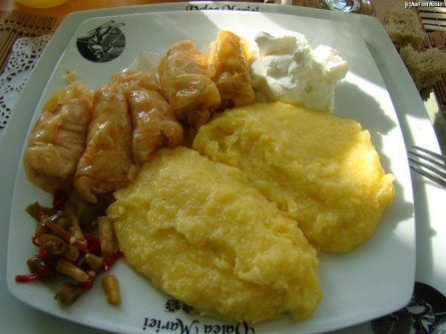
After dinner, the four children talked much about themselves and the next
day’s program.
In the morning, slightly sleepy, Eras and Mus were awakened by the two brothers and together they served breakfast prepared by their mother. Warm milk and slices of toast were accompanied by two jars, one with apricot jam and the other with strawberry jam. The guests enjoyed delicious meal and the mother told them that jam home made.
They told her what a perfect housewife she was and also a good cook. After they finished eating, they returned to their rooms and got ready for the first sightseeing visit.
They were excited to visit Corvin Castle. They can not wait to reach the destination. Along the way, Adele and Michael's father told them that the castle was built in the XVth century by Ioan Hunyadi on Zlaşti river. It is provided with towers, bastions and a dungeon.
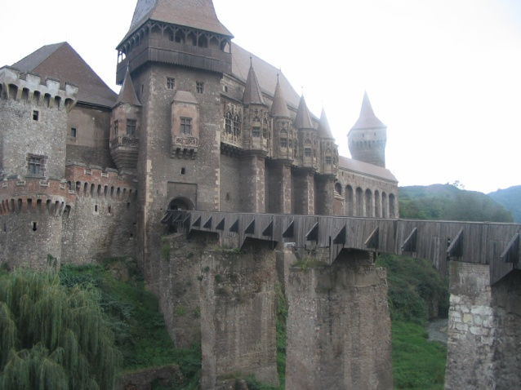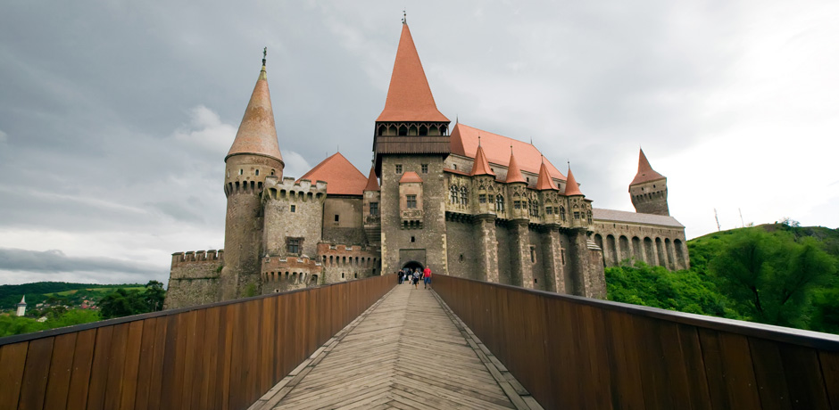
He was restored and converted into a museum. They were so caught up by the story that have not even noticed that they had come.
They left the car and ran to the entrance of the castle. They entered the castle. It was like they had returned in time. It looked exactly as heard.
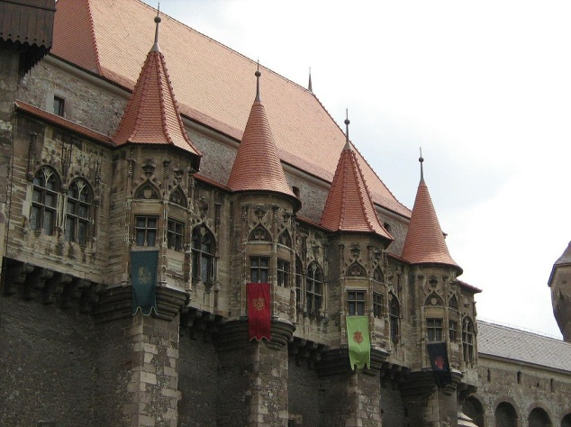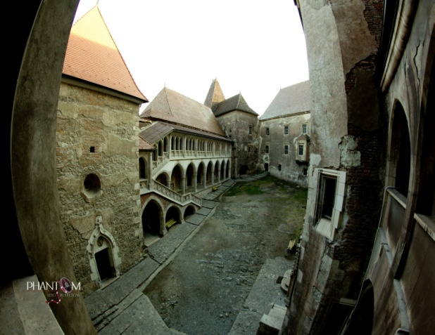

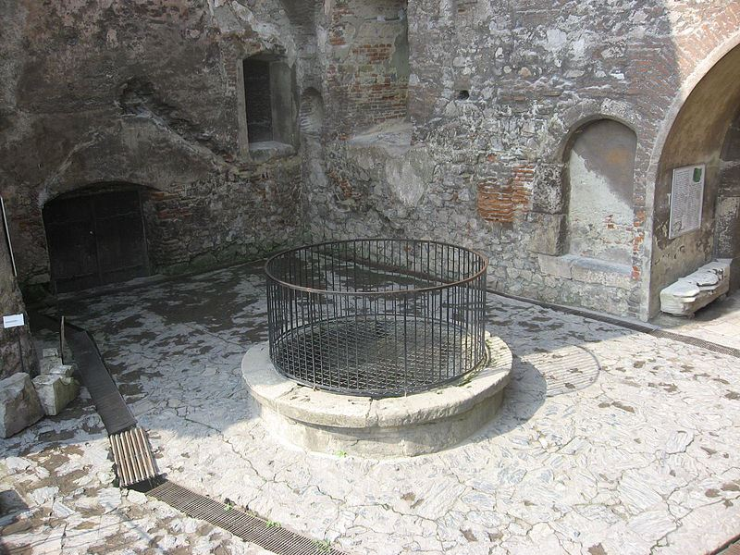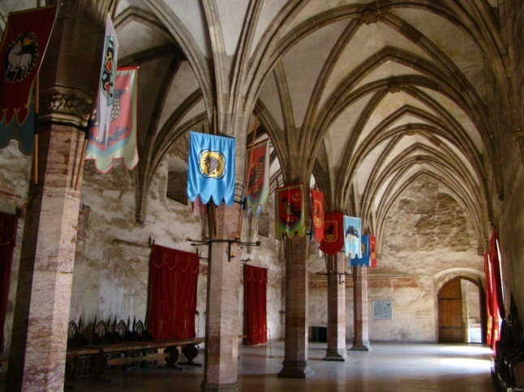
The castle rooms have been led by a guide who told them many curiosities children in Romanian history. He told them about the battle waged by Belgrade Hunyadi.
Children have been through torture chamber, where residents who disobeyed orders were punished.
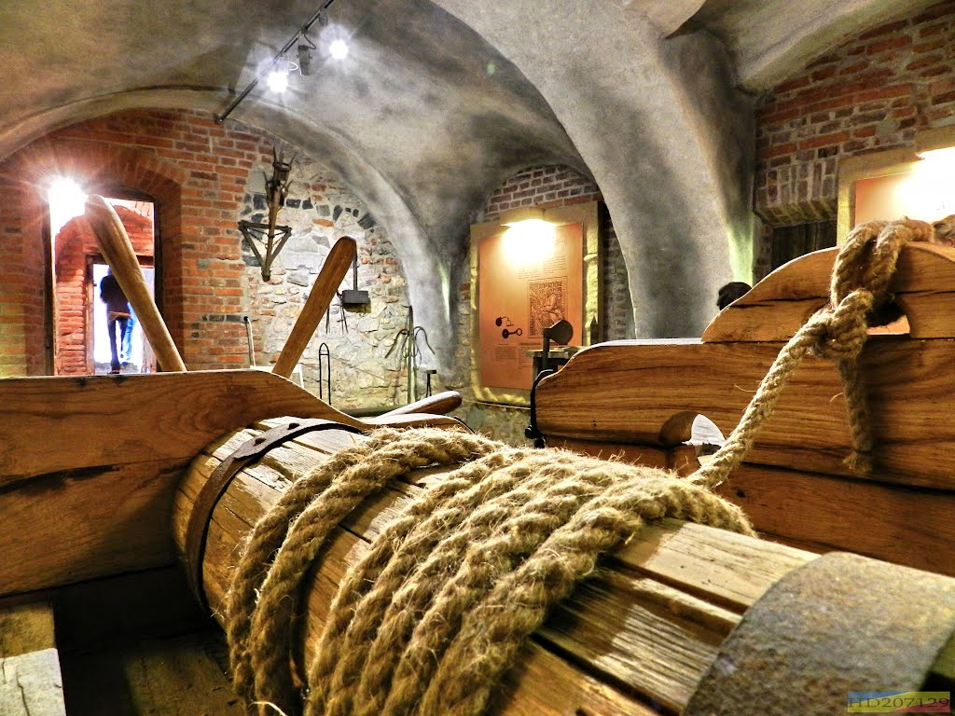

In one of the nearby castle there was an exhibition of medieval costumes and objects. Mus has become a brave knight with strong and sharp steel armor, and Eras, a princess with a tiara of gold on his head and a lovely medieval dress. They were delighted and, not to forget these moments, have made many pictures.
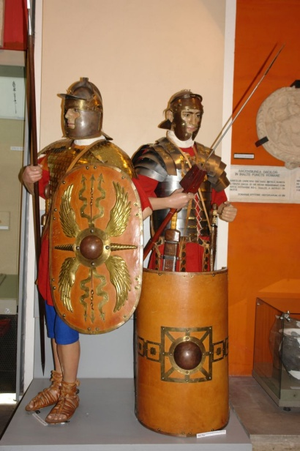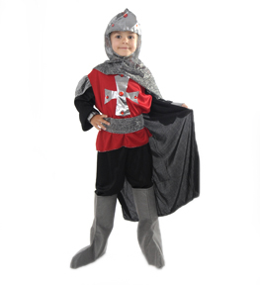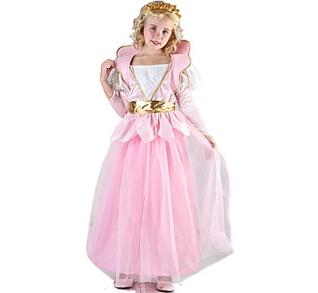

Walking the hallways, and the girl could hear voices as if the great rulers of the country. They visited and admired the great hall where the throne of thrones and other smaller ones around it.
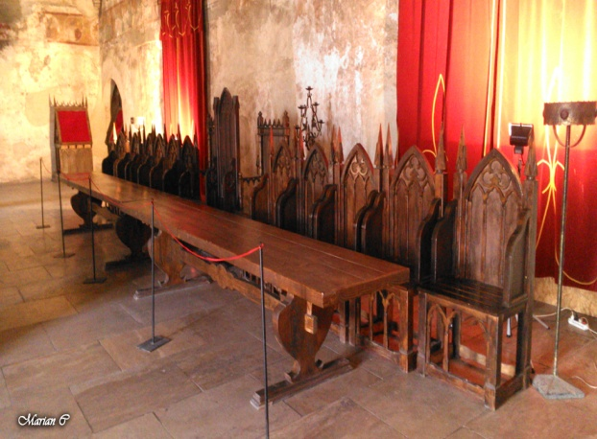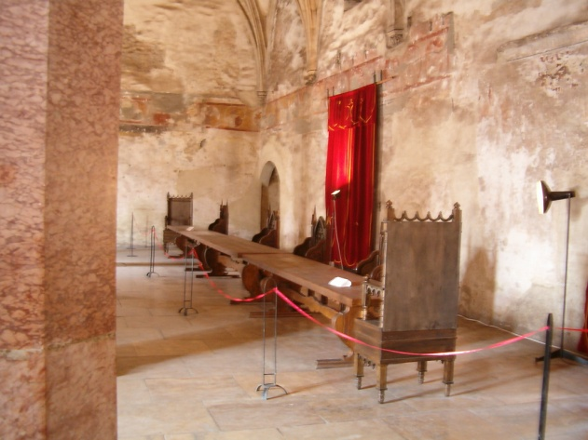
At the exit, they took their children each a souvenir and headed toward a Romanian restaurant nearby. They were served with a tasty tripe and potato pork stew. For dessert they had some steaming.
The day ended pleasantly and children have changed impressions about Hunedoara Castle.

The next day the children were waiting anxiously to attend the opening ceremony of Sighisoara Medieval Festival. They were informed that the festival takes place in ten sections: theatre, exhibition of books, film, dance, poetry recitals, conferences, presentations of weapons, medieval battles and public trials of witches the four children started sightseeing the streets of Sighisoara together with all those people dressed. They participated in the fighting soldiers and attended concerts . they were impressed by street dance with knights and ladies, they learned to shoot with bow and were thrilled by assisting in sentencing witches.
They left with beautiful memories and unforgettable moments.

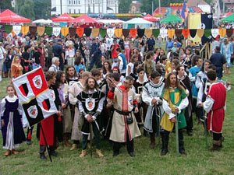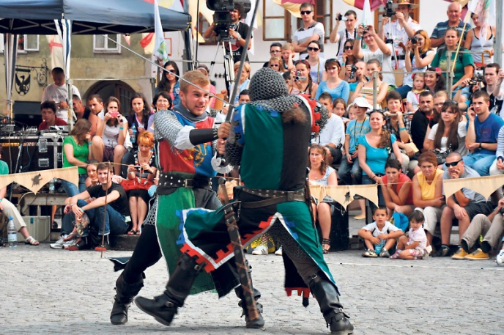

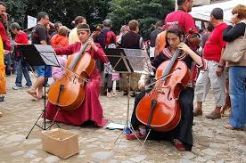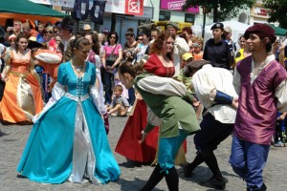

On the fifth day, Eras and Mus wanted to visit the great city of Sighisoara which they knew was very old and great. They learned that four hundred years ago a school was built and wanted to get there, where you had to walk three hundred steps through a tunnel. Another building which is well known is the city clock tower with a height of 64 meters and a tower-gate. Furriers Tower also viewed Weavers Tower, but none were as impressive as the clock tower.

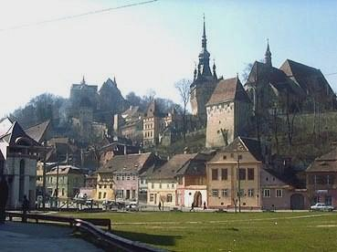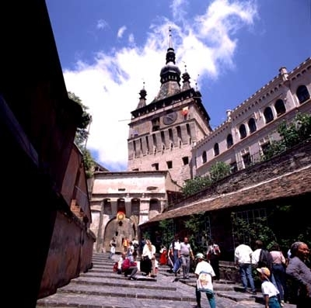

At the end of the day, the children returned home and ate Romanian cuisine. Eras and Mus spoke all the time about what to visit and confessed that they will really miss this country.
Given that there were only two days spent in Romania, the hosts were thought to make children aware of a shepherd from whom they bought a lot of good things, and he was not far from them. They wanted Eras and Mus to taste cottage cheese, Romanian specific.
Shepherd welcomed them warmly and invited them to his house. It was nicely arranged with antique furniture, many made by his hand the father and grandfather served with home made treats.

His wife gave the children a lot of goodies then.

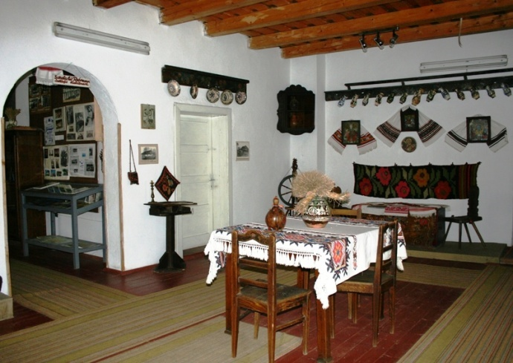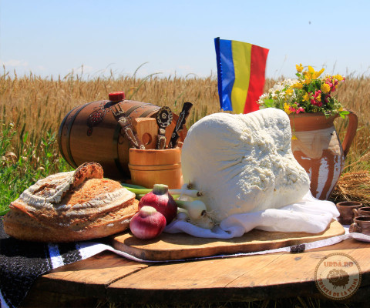
Then went to get acquainted with little sheep and shepherd dogs that defend them from the wolves. Sheep and dogs had thick and fluffy fur and for them it was a pleasure to comfort them.

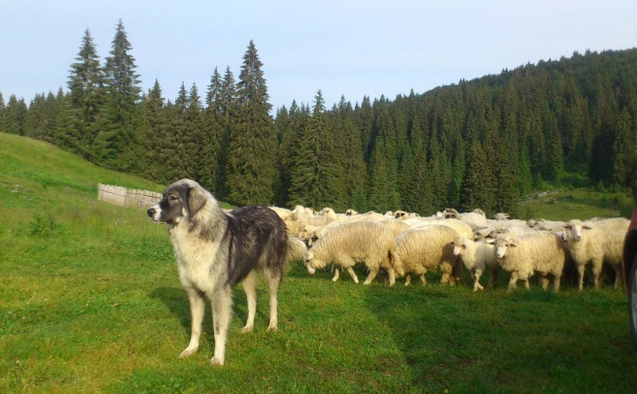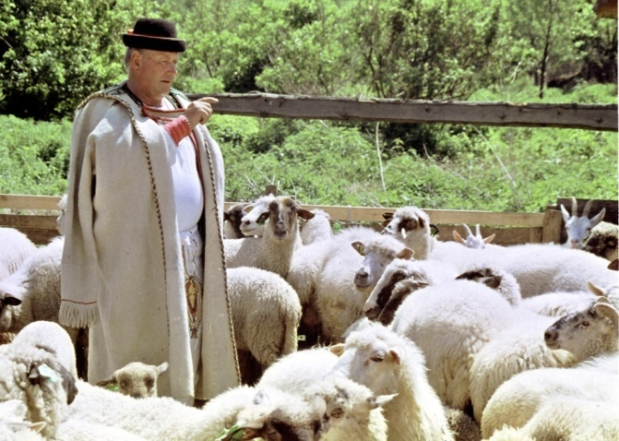

But the last day of the visit came! The whole family led to the airport. The departure was hard. The children really enjoied the places and their friends Adela and Michael and their animals and decided to return the next holiday.

