Könnis’ clock makers J. Yli-Könni 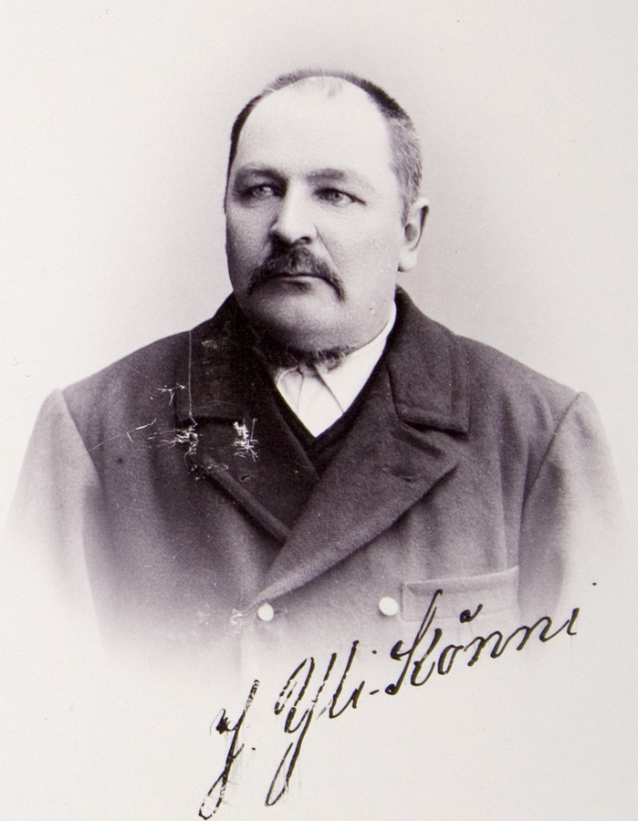 -- - Könni, the family who made grandfather clocks since 18th century.
The surname, Könni belongs to very known family in Ilmajoki, even in Finland. The forefather of this family was Jacob Jacob’s son (1721-1794). He was a blacksmith who moved to Ilmajoki in the middle of 18th century. He started to build wall clocks. Könni’s family made clocks in the middle of 18th century in Ilmajoki. Those first clocks were working only for a day. So you have to wound up it every day.
There is an effective machinery inside the clock. A machinery that made the clock peal was put to use in the end of the century. They called those clocks "repeteerikello" (cannot translate). This was a big innovation. There are seven pointers on Könni’s clock face. In the middle axle of the clock face there are four pointers: long and thin pointer for seconds, minute- and hour pointers, which were beautifully designed. In the clock face there are also two little faces, which both have got own pointers. One is pointing days and weeks and the other months. Above of the seventh pointer there was a ball, which presented the Moon. There are three, oval, brass weights and a pendulum in the locker. The clock peals full hours with two bells. At the night time when you cannot see the time, you tug a special rope and the clock repeats the hour, which was the latest (sharp hours).
Other clocks There are also table- and grandfather clocks. Likely they were not made for sale, only for oneself and for the family. Already 18th century the clock masters made also pocket watches. People from Stockholm (Sverige) ordered those and also clocks, which have owner’s name in clock’s face.
Könni started to make tower clocks in the beginning of 19th century. To make a clock like that it can take many months or even a year. Juho Könni made the first tower clock in workshop year 1822 and it is still working in the council of state in Helsinki.
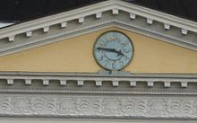 One of the Könnis’ watch is in the church in Ilmajoki.
Why do we think that Family Könni and the clocks are legends? Könnis’ family lived in Ilmajoki and still are living also in Ilmajoki. Long time ago they made clocks, which are very famous also today and the clocks are still working. –Henna and Meeri-

