Moustokouloura

Ingredients

• 500 ml must
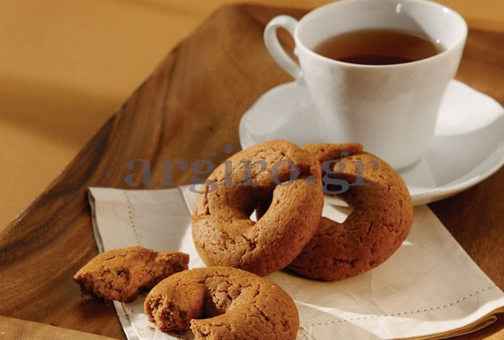
• 500 ml olive oil
• 250 grams sugar
• 2 tsp baking powder
• 1 tsp baking soda
• 1½ tsp cinnamon
• 1½ tsp clove powder
• 1 cup brandy
• 1½ kg flour

Preparation
1. In a large bowl pour the must, olive oil, sugar, cinnamon, cloves. Dilute baking soda in brandy. Mixing together.
2. Sieve the flour with the baking powder until you have a soft dough.
The Moustokouloura we make the round and put them in the oven.
3. Bake the buns at 170 degrees Celsius for 40.

