Eras and Mus in Nopankyla
by Jere K. Veeti, Jesse, Emilii, Ville and Jere P /drawings by the 1st and 2nd graders

The first chapter
Eras is a nice 12-year-old girl. She is tall. She has got blue eyes and blond hair. Her hobbies are ballet and acrobatics. She is really good in ballet. She has been a star in children acts many times. Acrobatics is good too. She needs soft movements in ballet.
Eras has got a cat named Kitty. She is fast and healt cat. She likes to go around Eras’es shoulders.

Mus is a boy, 13 years old, impish and reckless, but has common sense. His hobbies are scouts, football and fishing. Fishing is his favorite hobby. He has been in Finland, Norway, South Africa and Asia fishing different fishes. He also have tried fly fishing, but he didn’t like it. He likes the most spinning rod. He has been fishing with his father and uncle. They have had fun trips together.
Mus has got a white, havanna dog named Dogi. He is fast and really good at his movements.
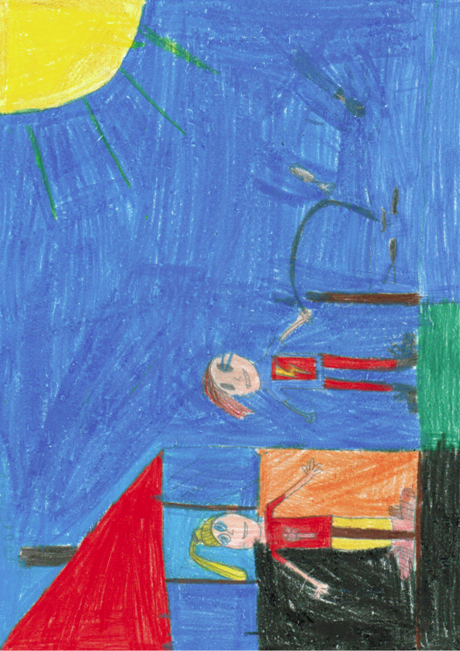
Eras and Mus are now in Finland. It’s their school trip. They are visiting a village named Nopankyla, in Ilmajoki. They have been there for the past week. They have had lot of fun to do.

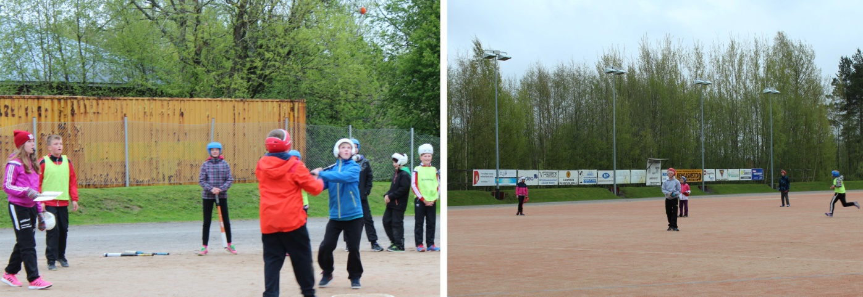
They have played Finnish baseball, basketball, made a boat trip, swam and fished. They have slept at the camp on the beach of the lake Kalajainen.
Today they are going to see Finnish nature and animals. They have heard it’s beautiful. They have already seen cranes, a bear, a raccoon dog and a lot of Finnish nature.

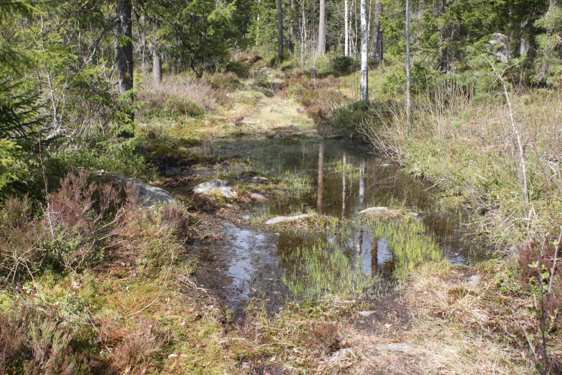

They think that the air is so fresh and clean in Finland.
In spite of the fact that Eras and Mus are siblings, they are a pair because of coincidence. That’s why they need to look after each other.
Mus is bored because he has already been in Finland many times. Eras is still interested in Finlands beautiful nature and animals.

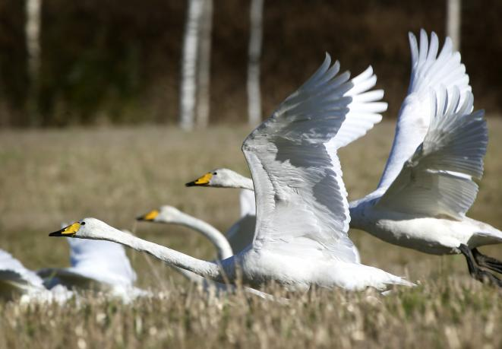

-Look, swans! Over there in the field! teacher yells.
-They are so beautiful, says Eras.
At the same time Mus sees a snake and goes after it. Eras sees that Mus is going to go further and because Mus is her brother she needs to go after him. They run couple hundred meters into the forest. Finally they run to ducboard where Eras catchs Mus. Eras is very mad to Mus, but she is just looking around.
-Where are we? asks Eras.
Mus answers: -I don’t know.
They see a sign that says ”Craine’s circle”.
-I knew that you shouldn’t have chased that snake! Eras is very grumpy.
-I can’t resist that, You know me, but didn’t the teacher said that we are going back along ”Craine’s circle”, Mus says. ”Craine’s circle” is a long path which goes in a forrest near Kalajainen.
-That’s right. Good thought, Mus, I didn’t remember that. Good job! Eras says happily.
In one point Kitty-cat starts hissing and at the same time Dogi starts to bark. Mus and Eras are confused, before Mus sees a snake that the pets saw. Mus does remember the warnings of his teacher, his sister and his parents, but in spite of those he still wants to disturb the snake. It’s get angry and bites Mus. After some time Mus starts to feel sick and dizzy. Eras notices that and graps Mus just before he falls down. Suddenly Mus disapieres from the ground. Eras is shocked!
-Where did he disappear, says Eras having a fear in her voice. Eras needs to calm down and start to search for Mus.
She shouts him by his name. -Answer, Mus, please!
Eras looks around if she could see any passers-by to help her to find her brother, but she doesn’t see anyone.

At the same time Mus walks up in some kind of field, where there is a cave and lot of stones in different size. He sees a sign that says ”Dude’s field”.
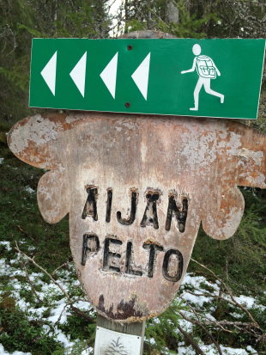

He remembers that their teacher has told them about some kind of ”Witch’s” and ”Dude’s” fields. A common name for this kind of field is devil’s field. The legent tells that one day the devil was so angry for some reason and threw big stones into fields near by. Because of that there was some outrocks or cliffs born. The truth is that devil’s fields are ancient beaches after ice age that show us the heigh where the old beaches has been. More than half of Finland has been under the sea, when the glacier retreated. At that time water flushed all sand away, leaving big stones behind, strong wawes eroded some boulders to devil’s fields and water rounded the stones so smooth.

The second chapter

Mus astonished because there was just a stone field, so huge around him.

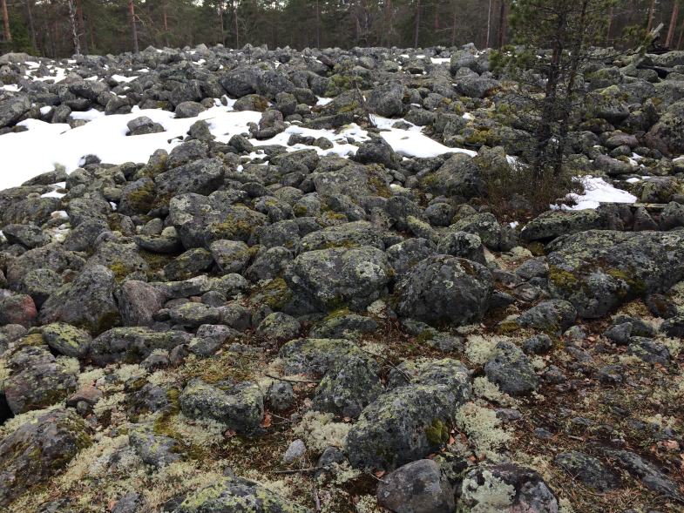
Mus sees just big stones covered with moss everywhere. He rubs his eyes awhile because he thinks that he is dreaming.
-Is there anyone here? he shouts.
His voice sounds very small in among those big stones of the stone field. Soon Mus hears the voice of Eras in the forest behind stonemunds.
-Eras is shouting for help! Mus thinks. He goes running on the stones in stonefields to find Eras. He needs to take a breath from time to time, because running on the stonefield is pretty hard.
-How long does this field continues? Mus thinks brethly.
Mus looks behind him to see, how long he has been running and crashes to a fallen tree. He hits his leg and stays to hold it for awhile.
-I have to keep going, because Eras is shouting for help in the forest, Mus agonises. Then he keeps going his hard trip in spite of a hurting leg.

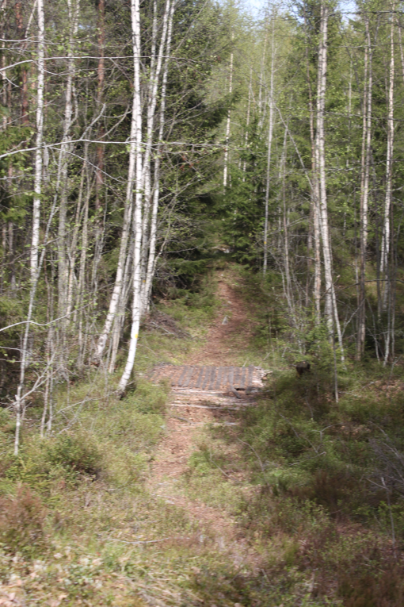

The forest comes closer and closer every step and after a long and hard journey, he arrives to forest. He sees Eras and hastens his speed. Mus and Eras are so happy when they see each others.
-Your leg, Mus, what has happened?
Mus answers: -I hit it to a fallen tree, when I was running here.
-Does it hurt? asks Eras.
-I’ll be fine, says Mus.
-Okay.. Where are we and how did we get here? wonders Eras.
Mus starts his way: -I don’t know. But it’s useless just stand here.
-I agree. Maybe we could go to look for some human settlements and ask them where we are? Eras gets a little bid excited.
Mus: -Good idea!

They start walking along the stonefield to find human settlements. Mus is agile because of his football hobby, but Eras is so tensed that she stumbles because of the stones so that seh hits her head and faints. Mus keeps going along the stonefield to another dark, green forest and doesn’t notice that Eras fell. The air is so clean, that the black bearcd moss is growing there.
-This is a good place to make a campfire, Mus thinks to himself. As good scout Mus is looking for some sticks to make the fire when he notices that Eras has vanished somewhere.
-Eras, where are you? shouts Eras now frightened: –Eras, answer me! He notices that Eras, Kitty and Dogi weren’t aboard!

Mus starts to go frigtened back to the stonefield. He finds Eras, laying fainted between stones, and Kitty and Dogi. The pets are so sad. They tear Eras from her clothes.
-Move a bit farther away, I’ll try to wake Eras up, Mus says to the pets. Mus tryes to wake up Eras, but she is still unconscious.
-From where did we come, says Mus in a panic:- This is a scary place in this darkness. I don’t wonder if there is some kind of Caveman living here!
Eras wakes up, stares fearfully and says very weakly:-Help!
What now, asks Mus and sees that Eras faints again. Mus looks behind him...

The third chapter

Mus sees extremely solid, three-meter-long, dark-haired and beard having Caveman. Mus frights and goes a little further to look at the situation.
Mus says: -Bu-bu-but what?
Caveman walks to fainted Eras, so Mus starts already fear the worst. Mus starts to shout Caveman:
-Hi, you! Leave my sister alone!
Caveman roars: -Mrh!
-Didn’t you hear? Leave my sister alone! She hasn’t done anything wrong to you! says Mus rasing his voice at the same time.
Eras's cat Kitty gets frightened for Caveman and runs away. She runs right in front of a fox. The fox tries to get Kitty as a snack. Kitty, however, is well trained and she hisses so hard that the fox leaves, the tail between it's legs.

When Caveman has raised Eras from stones, he sees Mus and starts to chase Mus. Mus is agile and fast, thanks to football. He runs away from stonefield, through the thick, dark green forest, but Caveman is still close to him. Mus decides to jump behind of fallen tree to hide. Caveman jumps over the trunk and continues running.
Mus: -Phew! That was close.
Mus sees a little bit of his dog, which runs right to the bear's lair. The bear wakes up from it's daydreams and get angry at Dogi. Dogi runs so fast as he can with his short legs. Bear cathces up Dogi, but Dogi slips between bear's legs. Dogi is safe.

Mus starts to walk to the way where from he came hoping to find human settlements.
But instead of that he hears heavy footsteps from his back.
Mus moans: -Not again...
Mus starts to run away from Caveman. He runs through the thick, dark green forest and stumbles on the stonefield.”
When the stonefield ends, Mus doesn't want to run anymore, he just is goint to surrende.
Mus: -Please don't do anything bad to me.
Caveman: -I don't.
It’s looks like Caveman tries to hit Mus, but he just wants to shake hands with Mus. And so they do. Soon Eras wakes up and he also meets Caveman. Caveman suggests to kids that they would eat something for snack.
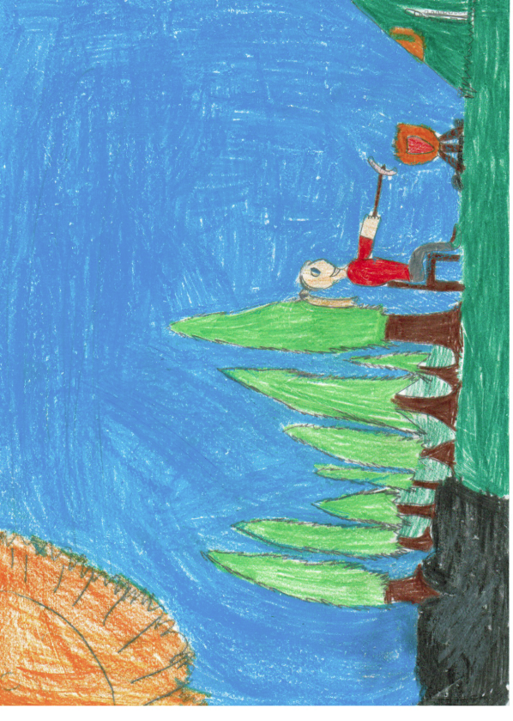
Mus suggests: -I can make fire. I am a scout.
Dogi and Kitty come to Eras and Mus. They are really dirty and filled of conifer trim.
Mus says: -I think they had really much to tell if they could speak our language.
-I don't wonder if after this all they could speak, snickers Eras.
Dogi and Kitty shout at the same time: -We can speak!
Eras looks at Mus: -Did you say something?
Mus asks in suprise: -No. I didn't. Did you?
Eras whispers: -No I didn't. It was caveman, I think.
-No, it wasn’t me. I haven’t spoke anything for a moment, says Caveman being a little bit suprised.
And they keep making snack.

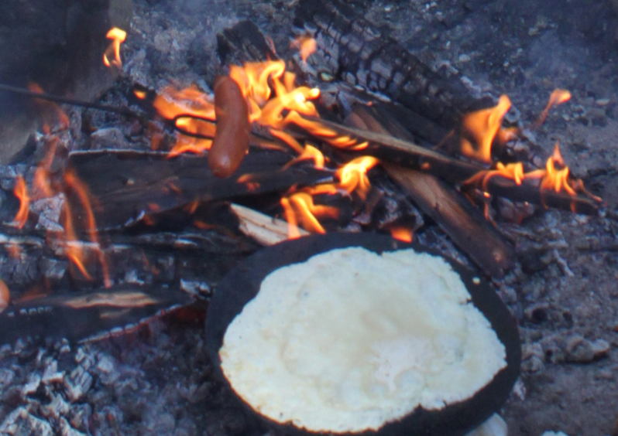

The fouth chapter

-So, my name is Caveman, and you are...?
-We are Eras and Mus! the kids were screaming at the same time.
Caveman has a shoulder extending long, brown hair and his beard whitc is long. Although the appearance will not be note! He is very old, but he look like young. He has been on ice so long time. Caveman raises Eras and Mus on his back.
-Where are you taking us? asks Mus hasty.
-I want to show you my home because after all you’re the only friends I have got.
-After all those journeys you have made? Eras wonders.
-We don’t want to get lost, says Mus.

The journey did not last long time. Caveman lives quite close to the rocky field. Caveman caletates Eras and Mus down from his back and leaves them to walk to the door.
-Have you built your house all alone? It’s awesome, exclaims Eras.
-Yes, only the wolfs helped me, says Caveman.
Kitty ans d Dogi are running next to Caveman. Eras wants Kitty to stop running. Kitty stops and waits from her owner some commands. Eras has trained her cat so well. She takes her cat in her arms and notice her cat purring with satisfaction. Mus wants to pet Kitty too, but he sees that his dog, Dogi looks so jealous, because Kitty getting all the attention. Mus sees his dogi an envious look and comes closer his dog and pets Dogi. Dogi starts to lick the face of Mus.The kids are walking near to the front door.
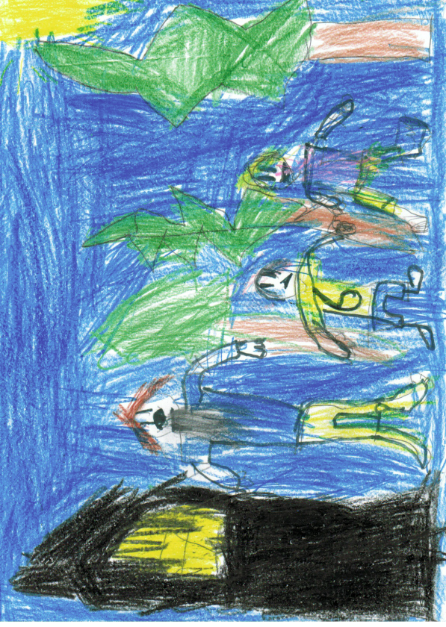
Caveman opens the door for them.
In the house they sit on a grim sofa. Eras is very curious and decides to inquire:
-How the wolfs are helping you?
-The wolfs are doing everything I ask them to do in the house, answeres Caveman.
-Where did you find the wolfs, asks Mus, because he wants to know one of the nature’s secret.
-I found a lorn wolf family someway during my journey, Caveman says promptly.
Eras and Mus look around Caveman’s house very enhusiastically. The house is made of big hole rocks, but the smell inside comes from soil. Eras doesn’t like the house or it’s smell. Eras wants to investigate the house in detail.
-Mus, do you want to come with me?
-Where do you want to go, asks Mus.
-I wanna check some places more closery, says Eras. – Caveman’s house, he wispers.
-Of course I want, but do you think that Caveman approves?
Eras approaches Caveman and asks him:
-Do you mind if we looked your house more radically?
-No, I don’t mind. Be my quests! I’ll go to kitchen to make a pie to have with tea, Caveman answeres unexpectedly.
Caveman goes to his kitchen and the kids are looking around but not finding anything special. Caveman’s house is not so big. They go back and have a seat from sofa. Caveman comes to them bringing tea and freshly baked pie with him. Eras, Mus and Caveman are cathering at the table. They talk, eat and drink tea. Children ask quetions about Caveman’s life and how he has inherited his name.
-The name is self invented. I liked the sound of that.
Then comes a long silence when nobody says anything. They only eat and drink. Kitty and Dogi are running and jumping in Caveman’s rooms.

The fifth chapter

Caveman wants to take them to some special place. The children ask: -Do you think it’s far?
It’s not so far, through some forests. You can came on my wolfpack, answered Caveman. Then he whistels some wolfs to them. -I have got seven wolfs.
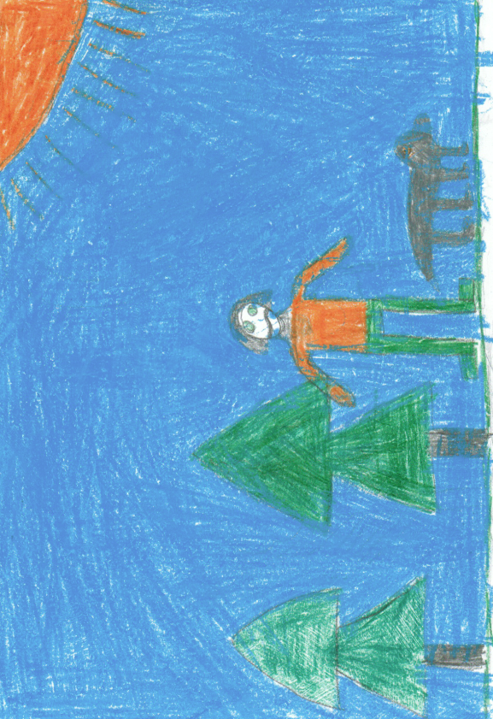
They are: Kur, Kurwa, Kurri, Murri, Turri, Lurri, Lurppis. The leader of the wolfs is Kur.
Caveman continues coutning: -One, two, three, four, five, six... Ok, now we can go. Oh no, one wolf is still missing. Where can it be?
Mus and Eras ask: -Where should it be?
Caveman thinks: It might be at my home.
-Can we go and check? asks Mus.
-Yes, we can. It’s coming there! Oh its not it.. It’s Kurri, I counted wrong, says Caveman being sorry.
Mus: -Now only Kur is missing..
Caveman notices:-There he come!
The children are thinking about going with Caveman. After a while they answer:
-Yes, we’ll come with you.

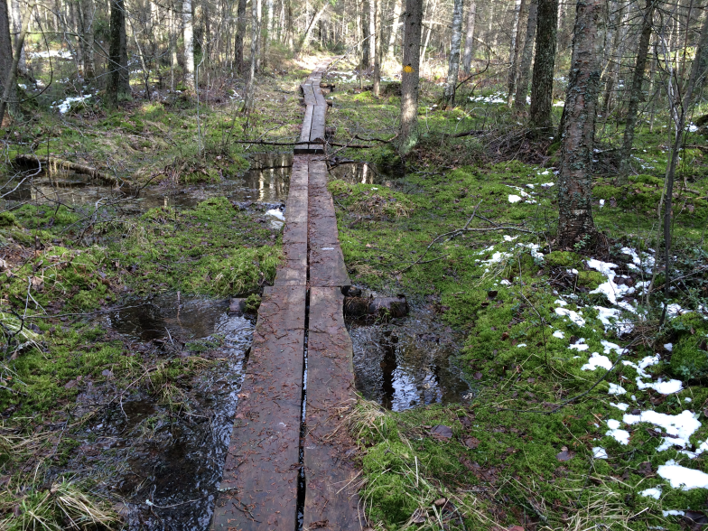

They go through thick forests. They lose their way one time, but they find the way again. Eras and Mus are amazed about where they are going?
They see many different animals on the way to the destination. When they see a bear, they are always thouhgt that bears attack humans, but no.

It is geting dark. Finally they are on their destination.
-What a small lake, admires Eras.

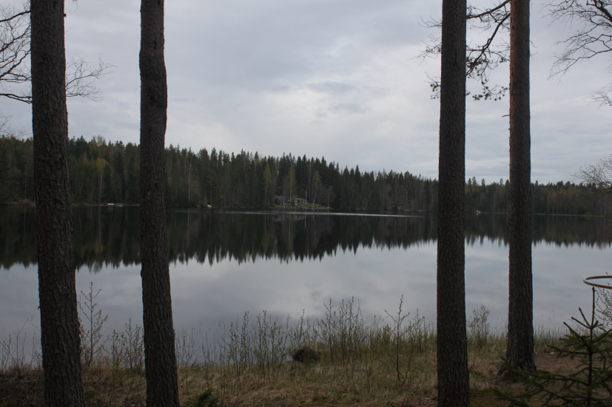
Mus : -Vau!
Caveman tells: -This is an old, small lake. It’s called Lake Kalajainen. I can tell you the story of this lake. Let’s sit on this stone.
And Caveman starts his story: -Behind us there was a golf-track. It is already unwinded. Now there is camping center owned by the church.
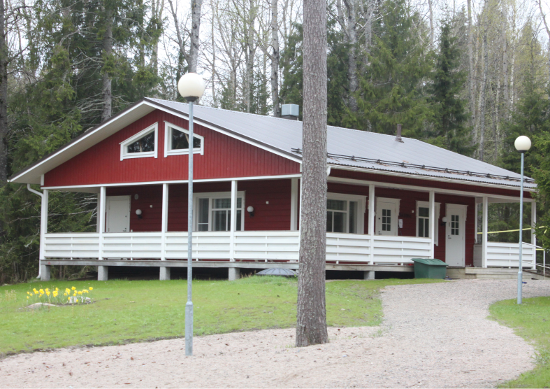

At the camping center we arrange many camps. Someone wants to rent it, because they contrive their partys there. The lake is the best marketer of this area. You can tell many kind of stories which happens in the lake or near it. It makes this area very popular. And Caveman continues his story...

After exciting story they all were very hot.

The sixth chapter

After awhile Mus says to Eras that they go swimming. The water is very warm so they swim in the lake Kalajainen for some time.
Suddenly they are back in Caveman’s house. They remember the snake biting Mus, and Eras losing his sister... Just then they woke up in their own beds!

