Cake with cinnamon and walnuts

Ingredients
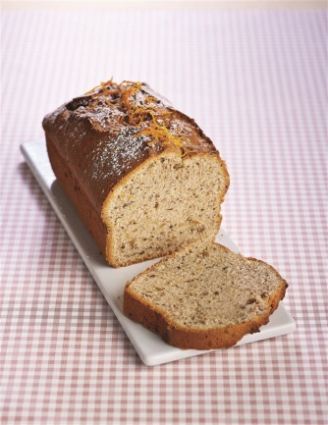
200 g. butter
200 g. sugar
4 eggs
340 g. flour
100 g. walnuts
5g. baking powder
zest of 1 orange
1 tsp cinnamon powder
60 ml orange juice

Preparation
Preheat oven to 170 ° C. In mixer, beat butter and sugar until fluffy and slowly add the eggs. Add flour, nuts, baking powder, orange zest and cinnamon and continue beating until they form a smooth mixture. At the end, add the juice and beat for a while yet.

Grease with butter and flour the cake form and fill with the mixture. Bake for about 45 minutes.

