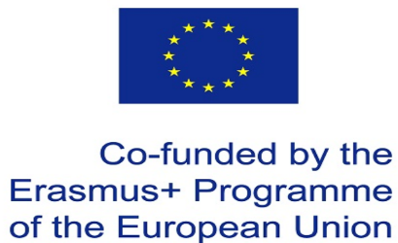 Teachers’ questionnaire 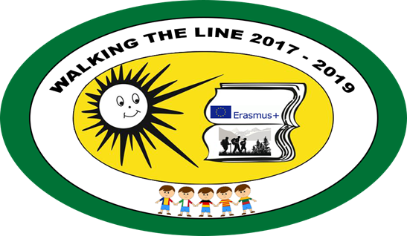
Participation in this project contributed to:
- Improvement of speaking skills in foreign language:
1- not agree 2- partially agree 3 –mostly agree 4- totally agree

- Better use of IT:

1- not agree 2- partially agree 3 –mostly agree 4- totally agree

- Better knowledge of European educational system:

1- not agree 2- partially agree 3 –mostly agree 4- totally agree

- Better knowledge of EU :

1- not agree 2- partially agree 3 –mostly agree 4- totally agree

- Better cooperation of all school teachers:

1- not agree 2- partially agree 3 –mostly agree 4- totally agree

- More school prestige in the community:

1- not agree 2- partially agree 3 –mostly agree 4- totally agree

- How do you rate this Erasmus+ project?

very good – good – okay – not good- wouldn´t take part in it again
- What was your first impression of Lithuania?
--------------------------------------------------------------------------------------------------
9. What similarity between your cultures did you see? (please give the most important one)
10. What difference between your cultures did you see? (please give a most important one)

