Walking the line

First stop: You can see many plants, flowers, trees and the columns are very beautiful as they are made. | Latitude:  41.384937  N 41º 23’ 05’’  Altitude:  130.27 m  Distance:  0 m | 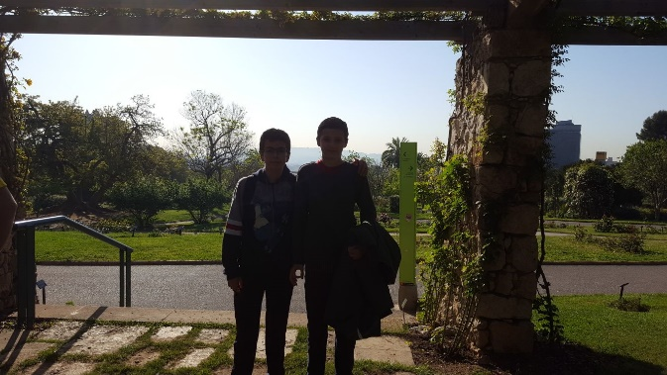
Second stop: You can see all Barcelona, ​​it is a place where you can rest and see good views. | Latitude:  41.403836  N 41º 24’ 13’’  Altitude:  309.09 m  Distance:  1942 m | 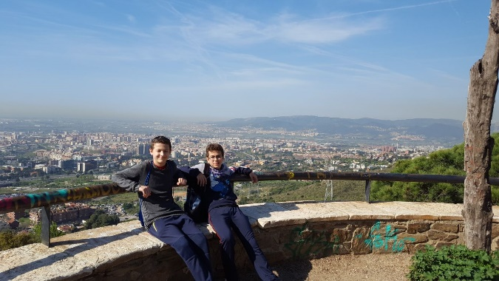
Third Stop: You can see a small field, trees and a village. | Latitude:  41.393904  N 41º 23’ 38’’  Altitude:  337.16 m  Distance:  6582 m | 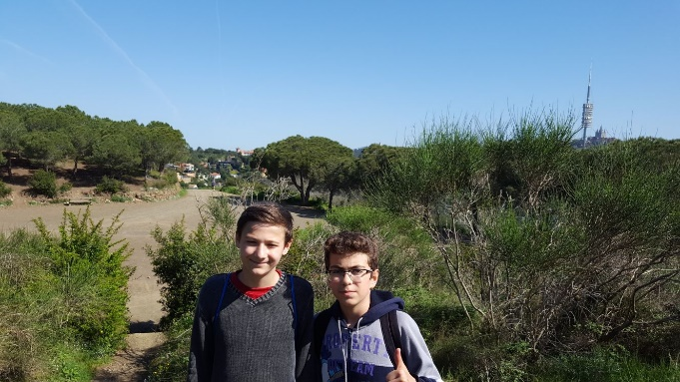
Fourth Stop: You can see a communications tower, more trees and a bit of landscape. | Latitude:  41.389859  N 41º 23’ 53’’  Altitude:  398.31 m  Distance:  7540 m | 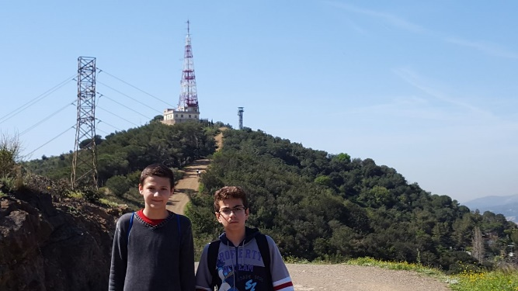
Fifth Stop: You can see a large Cypress, a small mountain, a place and a place for a picnic | Latitude:  41.389870  N 41º 23’ 23’’  Altitude:  337.72 m  Distance:  11404 m | 