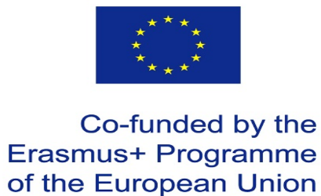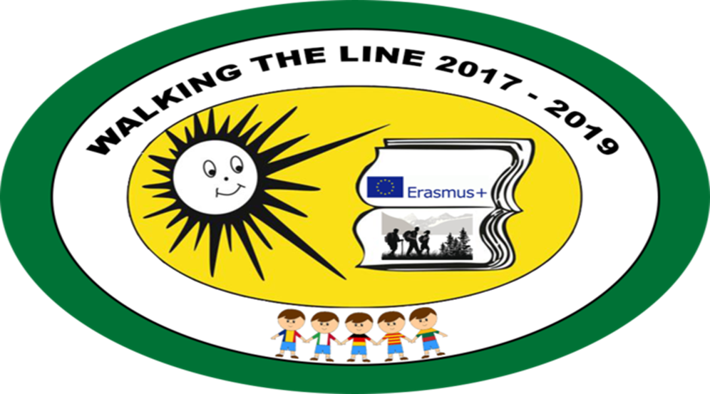
Teachers’ questionnaire
Participation in this project contributed to:
- Improvement of speaking skills in foreign language:
1- not agree 2- partially agree 3 –mostly agree 4- totally agree
Result 10 teachers – totally agree

- Better use of IT:
1- not agree 2- partially agree 3 –mostly agree 4- totally agree
Result 10 teachers – totally agree

- Better knowledge of European educational system:
1- not agree 2- partially agree 3 –mostly agree 4- totally agree
Result 10 teachers – totally agree

- Better knowledge of EU :

1- not agree 2- partially agree 3 –mostly agree 4- totally agree

Result 7 teachers – totally agree, 3 mostly agree

- Better cooperation of all school teachers:

1- not agree 2- partially agree 3 –mostly agree 4- totally agree
Result 10 teachers – totally agree

- More school prestige in the community:

1- not agree 2- partially agree 3 –mostly agree 4- totally agree
Result 6 teachers – totally agree, 4 mostly agree

- How do you rate this Erasmus+ project?

very good – good – okay – not good- wouldn´t take part in it again
Result 10 teachers very good

- What was your first impression of Lithuania?
-----2- green country. 3 clean country.-2 many lakes and forests. 1beautiful nature.-1 punctual people.---1-interesting history.---------------------------------------------------------------------------
- What similarity between your cultures did you see? (please give the most important one)
3 food, 6 colorful trees in autumn,
10. What difference between your cultures did you see? (please give a most important one)
7 different education system, 3 nothing.

