Report for Erasmus+ project impact ”Walking the line”

- Results of Lithuania .
In Marijampole “ Ryto” basic school, students who were observed by teachers or counselors as having behavioral problems were invited to take part in project “Walking the line” physical-activity sessions which were held weekly. During this report, this group of students is called “Physical Activity Group”.
Country ,school | Physical activity group |  | Countrol group
Lithuania Marijampole Ryto basic school | Pre-test  26 | Post test  23 | Pre-test  10 | Post test  9

However, statistically significant differences are difficult to detect with such low sample sizes. Therefore, besides the reported statistically significant differences, decreasing or increasing trends in psychological problems should be attended in the presented figures.

Results Regarding Level of Depressive Symptoms
A 2 X 2 Mixed Factorial Analysis of Variance (ANOVA) on depression scores was conducted with group ( physical activity vs. control) as the between subjects factor and time (pre-test vs. post-test) as the within subjects factor. The results showed a significant main effect for group, F(1, 30) = 9.50, p < .01, partial .² = .24. Regardless of time of measurement, students taking part in the physical-activity sessions (M = 1.61) reported lower depression compared to students in the control group (M = 2.06). The main effect for time and the group X time interaction were found non-significant, Greenhouse-Geisser adjusted F(1, 30) = 1.53, p > .05 and Greenhouse-Geisser adjusted F(1, 30) = 2.28, p > .05, respectively (Figure 1).
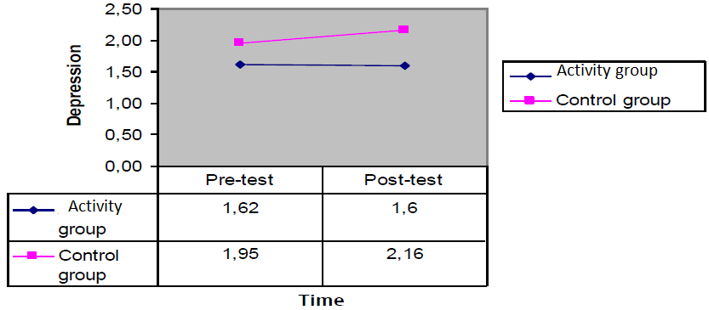
Figure 1. Physical activity Group and Control Group Depression Scores in Lithuania
Because the sample size in each cell is low, especially for the control group, the pre and post test depression means were also compared by two different paired samples t-test for the physical -session group and the control group, separately. For students who took part in physical activity sessions, there was not a significant difference in depression scores for the pre-test (M = 1.62, SD = 0.40) and post-test (M = 1.60, SD = 0.39) conditions, t(22) = .26, p >.05. Specifically, results suggest that the physical sessions student took part did not decrease their depression scores. Similarly, for students in the control group, there was not a significant difference in depression scores for the pre-test (M = 1.95, SD = 0.49) and post-test (M = 2.16, SD = 0.44) conditions, t(8) = -1.68, p >.05.
Results Regarding Level of Anxiety Symptoms
A 2 X 2 Mixed Factorial Analysis of Variance (ANOVA) on anxiety scores was conducted with group (physical activity vs. control) as the between subjects factor and time (pre-test vs. post-test) as the within subjects factor. The results showed a significant main effect for group, F(1, 30) = 4.70, p < .05, partial .² = .14. Regardless of time of measurement, students taking part in the physical-activity sessions (M = 1.68) reported lower anxiety compared to students in the control group (M = 2.03). The main effect for time was found non-significant, Greenhouse-Geisser adjusted F(1, 30) = 2.84, p > .05. There was a significant group X time interaction, Greenhouse-Geisser adjusted F(1, 30) = 4.69, p < .05, partial .² = .14 (Figure 2). Simple effects analyses were conducted for group at each level of time, with each test conducted at an alpha level of .025. The results of the simple effects tests indicated that there was not a significant difference between pre and post-test anxiety scores for the physical-activity group, t(22) = .45, p > .05. On the other hand, there was marginally significant difference between pre and post-test anxiety scores for the control group, t(8) = -2.28, p = .05. Specifically, anxiety scores of the students in the control group increased from pre-test (M = 1.85, SD = 0.46) to post-test measurement (M = 2.20, SD = 0.41). factor. The results showed a non-significant main effect for group, F(1, 16) = .21, p > .05. Similarly, the main effect for time and the group X time interaction were found non-significant, Greenhouse-Geisser adjusted F(1, 16) = .20, p > .05 and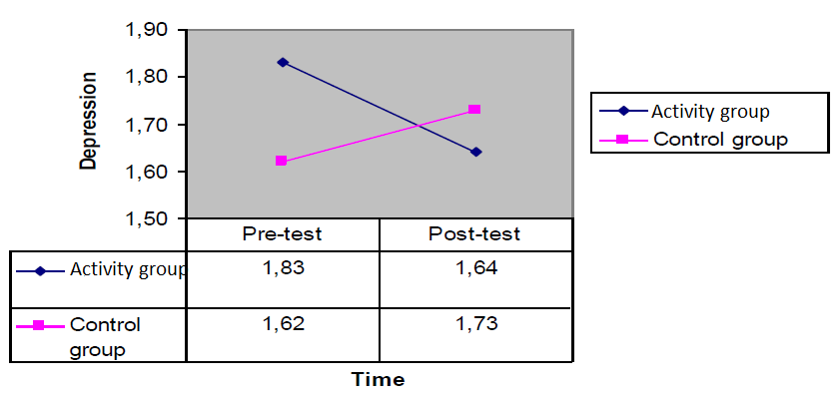 Greenhouse-Geisser adjusted F(1, 16) = 3.03, p > .05, respectively (Figure 4).
Figure 2. Physical-activity Group and Control Group Anxiety Scores in Lithuania
Results Regarding Level of Total Problems
A 2 X 2 Mixed Factorial Analysis of Variance (ANOVA) on total depression/anxiety scores was conducted with group (physical activity vs. control) as the between subjects factor and time (pre-test vs. post-test) as the within subjects factor. The results showed a significant main effect for group, F(1, 30) = 6.62, p < .05, partial .² = .18. Regardless of time of measurement, students taking part in the physical -activity sessions (M = 1.66) reported lower total depression/anxiety compared to students in the control group (M = 2.04). The main effect for time was found non-significant, Greenhouse-Geisser adjusted F(1, 30) = 3.10, p > .05. There was a significant group X time interaction, Greenhouse-Geisser adjusted F(1, 30) = 5.01, p < .05, partial .² = .14 (Figure 3). Simple effects analyses were conducted for group at each level of time, with each test conducted at an alpha level of .025. The results of the simple effects tests indicated that there was not a significant difference between pre and post-test total depression/anxiety scores for the physical -activity group, t(22) = .45, p > .05. On the other hand, there was marginally significant difference between pre and post-test total depression/anxiety scores for the control group, t(8) = -2.29, p = .05. Specifically, total depression/anxiety scores of the students in the control group increased from pre-test (M = 1.88, SD = 0.47) to post-test measurement (M = 2.19, SD = 0.40).
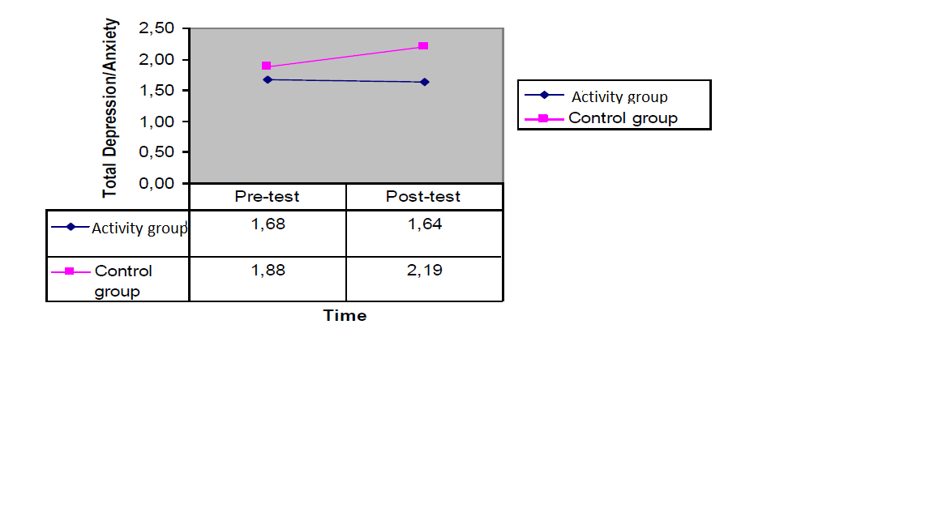
Figure 3. Physical -activity Group and Control Group Total Depression/Anxiety Scores in Lithuania
To sum up, when the pre and post test conditions were compared in Lithuania data, it seems that physical sessions did not make a significant difference in depression, anxiety, and total problem scores. However, it is evident that students have marginally higher anxiety and total depression/anxiety scores in post-test condition compared to pre-test. It could be said that physical-sessions might have a protective role against increase of psychological problems, such as depression and anxiety.

