LET’S EXPERIENCE AND LEARN
EXPERIMENT 4 THE STATIC ELECTRICTY
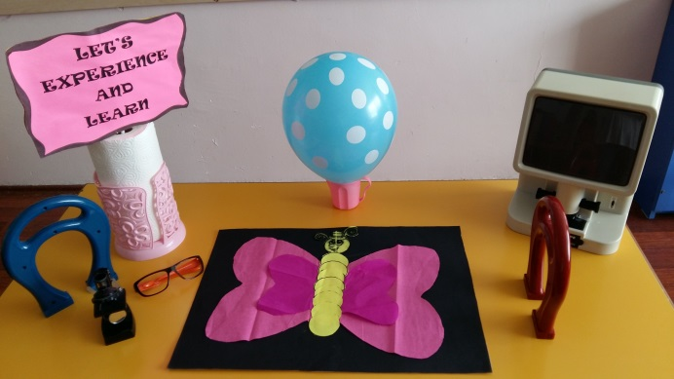
MATERIALS
*Balloon
*Paper Butterfly

WORK PLAN
-Blow up a balloon and rub it in your hair to give it electricity charge. Now hold the balloon on top of your butterfly close enough and watch the wings raise and lower as you move the balloon closer and farther away.

-Our hair looses electrons that are gained by the balloon giving it a static charge. When negatively charged balloon gets close to the positively charged tissue paper they are attracted to each other, and so tissue paper moves towards the balloon.

