LET’S EXPERIENCE AND LEARN
Winter Experiment
„ICE HANDS“
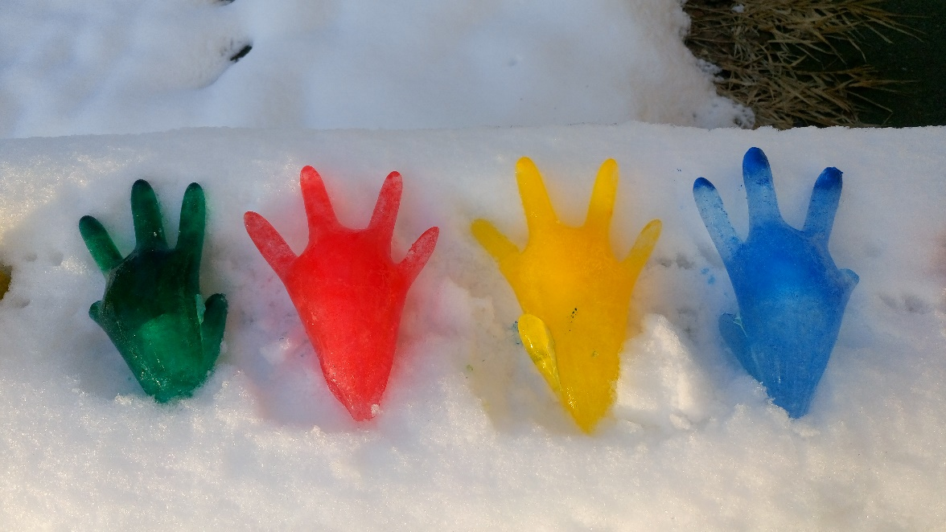

MATERIALS:
1. Latex gloves
2. Water
3. Food coloring
4.Twine
5.Shallow baking pan

- Fill a glove with water.
- Leave yourself a couple of inches at the top because you’re
going to have to twist it shut.
- Add a drop or two of food colouring, and shake the glove to
disperse the colour.
- Gloves tightly and firmly fastened with twine
- If outside temps are cold enough, place the gloves outside
or place the pan with the gloves in freezer overnight

The trick to minimizing any casualties is to run the gloved hand under a bit of water, and very gently slide the glove off. You have to take your time when you’re working on the fingers. You may have to dribble a little water into the glove, but be careful not to melt the fingers with the water.

