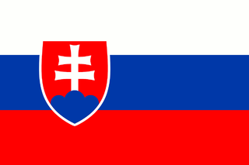
LET’S EXPERIENCE AND LEARN
Experiment 1

Magic BUBBLES
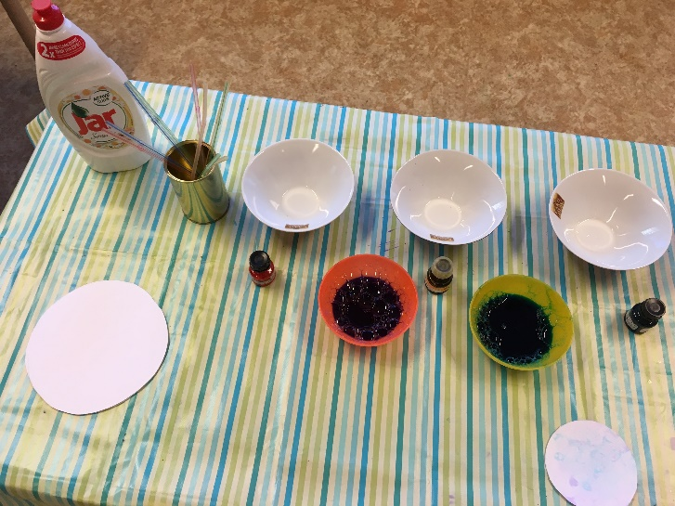
Materials:
- bowls
- water
- dish soap
- ink
- straws
- paper circles

Pour the water into the bowls. Add soap and ink to water. Stir well. Immerse the straw and blow the air into it. Lay the paper circles on the bubbles.
Hooray!
Here are the colored bubbles :)

