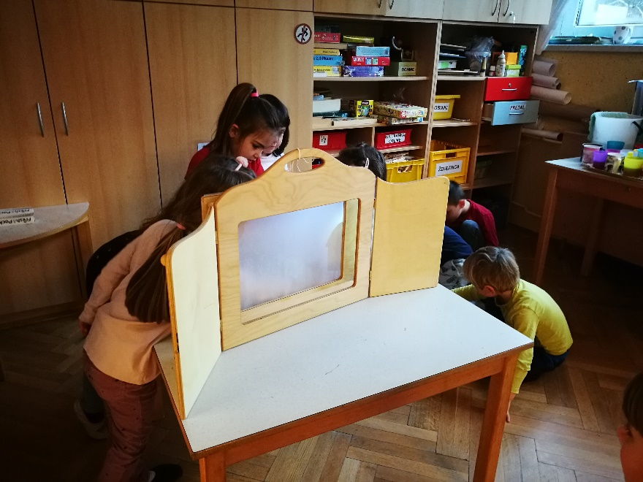

LET’S EXPERIENCE AND LEARN
EXPERIMENT 2
EXPLORING LIGHT
Learning Objective for Shadow Puppets: Investigate the properties of shadows.
MATERIAL:
scissors
sheets of paper
wooden sticks
pencil or craft stick
tape
flashlight
scaffolding for kamishibai and puppet shows (or a box - Shadow puppet theatre made with a cereal box, wax paper, a lamp and a darkened room)
a story
Read a story. We read a story of Three pigs .
Draw and cut the basic shapes .
Explore what happens when and how the shadow puppet moves.
Have a puppet theater story.

