LET’S EXPERIENCE AND LEARN
EXPERIMENT 4 (Dragon snot)
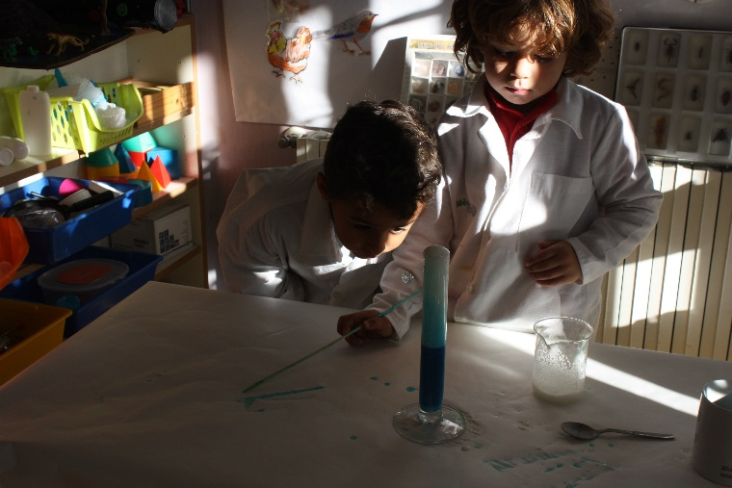

MATERIALS
1.OXYGENATED WATER
2.COLOURING
3.SOAP
4.WATER
5.YEAST
WORL PLAN
- Put oxygenated water with colorant and soap.
- After that put de water and yeast.
- Merge it all.
- Finally you have “Dragon snot”

