LET’S EXPERIENCE AND LEARN

EXPERIMENT 2 RIAN
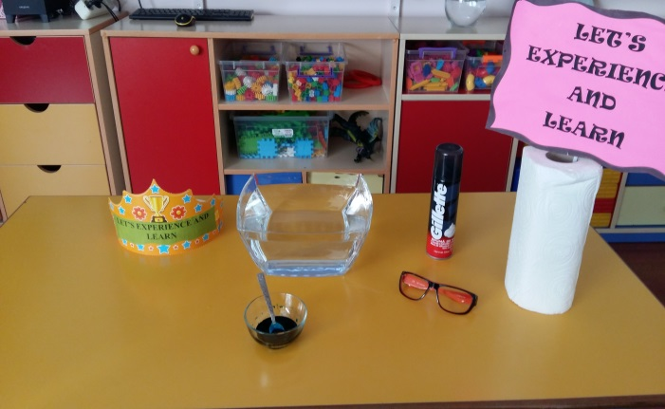
MATERIALS

- SHAVED FOAM
- WATER
- BLUE PAINT

WORL PLAN
- The plate is filled with water.
- The shaving foam is poured on to the water.
- Shaved foam is described as cloud.
- Blue paint is placed on top of your shaving foam.
- Blue paint is described as rain.
- And watch the rain

