LET’S EXPERIENCE AND LEARN

Experiment 1

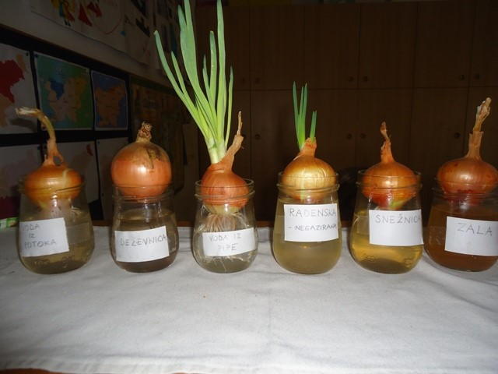
Onion experiment / How clean is a watter?
Materials:
onions,
water from different areas, ( Tap water, water in a bottle , mineral water (without CO2), rain water or snow water, water from a brook, lake, river.., other type if you found it…)
jars or cups (same size)
Put each onion into a glass of a different type of water.
Observe how onions grow. The one with the longest roots grows in a cleanest water.

