LET’S EXPERIENCE AND LEARN
EXPERIMENT 4 MIXING THE COLORS
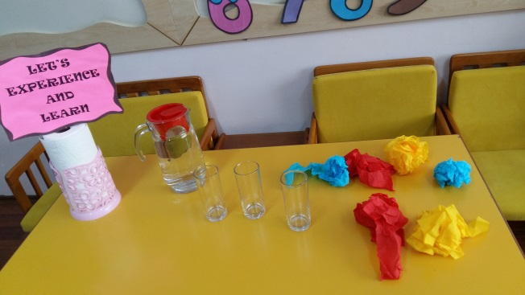
MATERIALS
*Water
*Glass
*Paper

WORK PLAN
-The three primary colors are red, yellow, and blue; they are the only colors that cannot be made by mixing two other colors.
The three secondary colors are green, orange, and purple; they are each a mixture of two primary colors. Their hue is halfway between the two primary colors that were used to mix them.
-We put papers into the glass. Later we add some water into the glass.
-and we sight.
red + yellow = orange
blue + yellow =green
red + blue =purple

