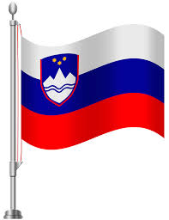

LET’S EXPERIENCE AND LEARN

Experiment 2
Exploring air
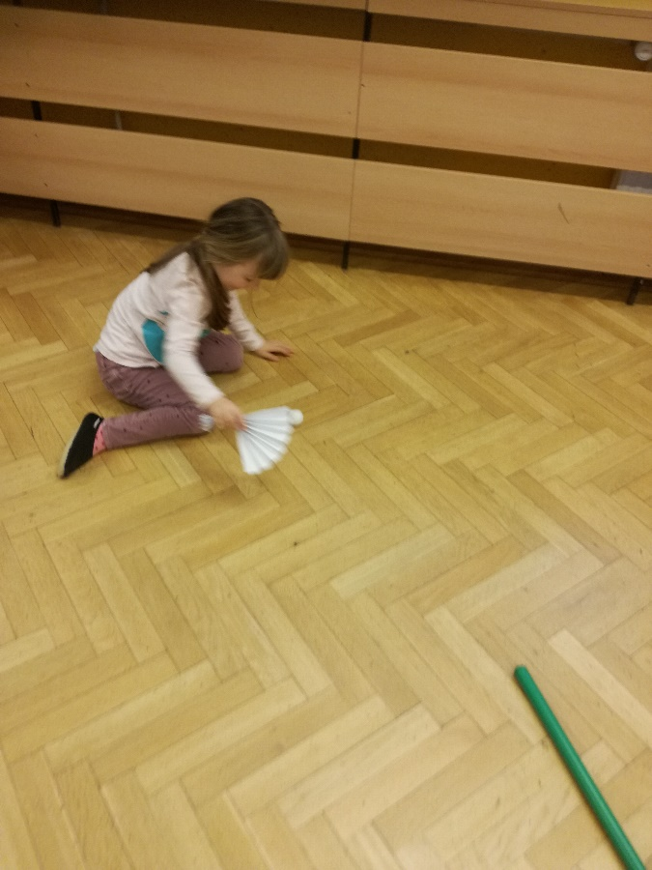
- MAKE A PAPER FAN:
https://www.wikihow.com/Make-Paper-Fans
- You can use it for cooling yourself
- Or for playing – try to move a ball (ping pong plastic balls)

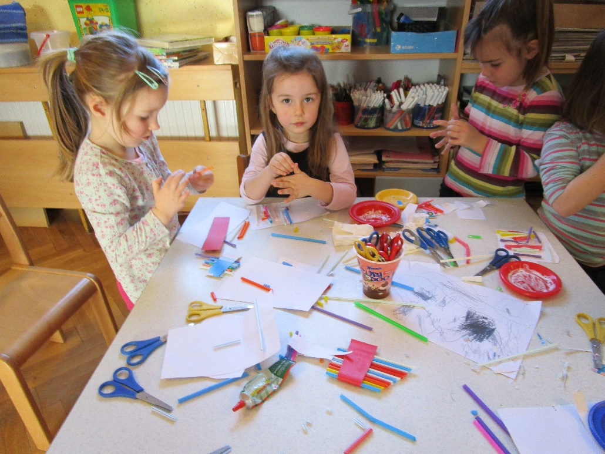
- MAKE A PAN FLUTE:
MATERIALS:
- plastic drinking strawssticky tape
- scissors
- a ruler
- pen or pencil
HOW TO DO IT?
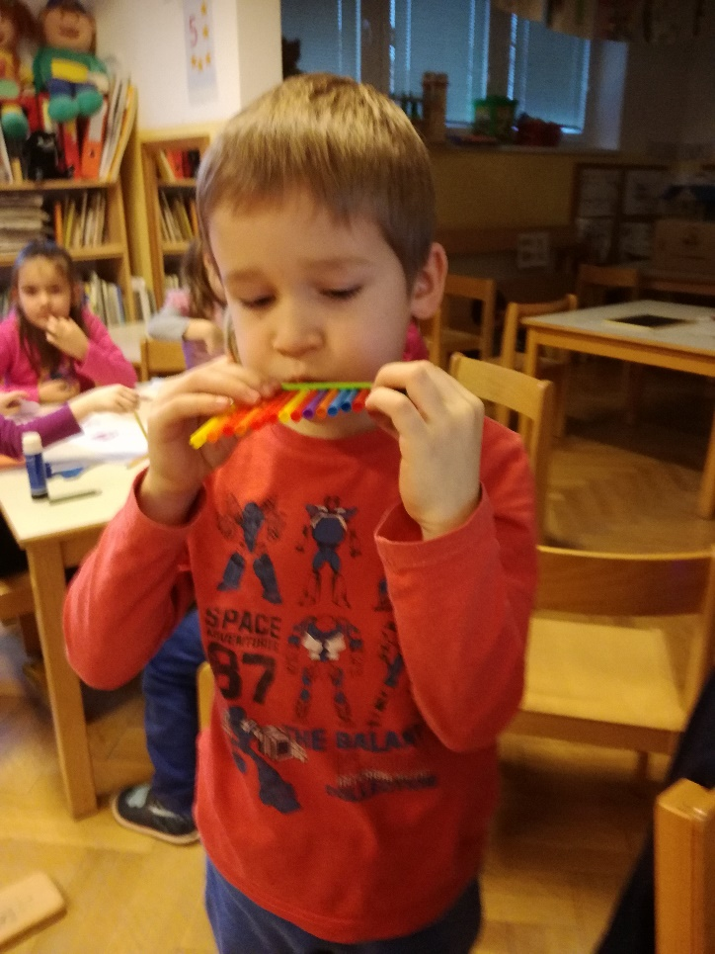
- Start by cutting your first straw at 20cm. Then the next straw will be cut 2cm shorter, at 18cm. Cut each straw 2cm shorter than the last until you have cut them all.
- Line up your straws longest to shortest.
- Sticky tape them together in that pan flute formation.

Enjoy in a music…

STRAW BLOWN PAINTINGS
Create some beautiful artwork by blowing colourful paint across the paper using straws!
Get the paint to move and dance across the paper.

Materials:
- Watered down paint, food colouring or liquid water colours
- A container for each colour of paint
- A spoon for each colour of paint
- Large sheets of paper
- Straws – one for each child

