LET’S EXPERIENCE AND LEARN

EXPERIMENT 3 THE SOARING LIQUID
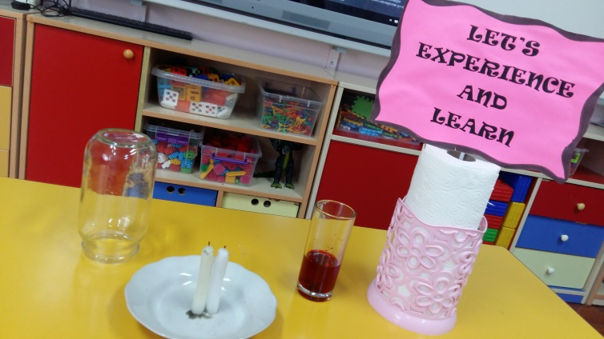
MATERIALS
*CANDLE
* RED WATER
*BOTTLE
* PLATE

WORK PLAN
- The first thing to do is to stick the candle to the plate
- Add the colouring in the water and stir.
- Put the glass bottle
- Pour the water in the place.
- And see what happens

