LET’S EXPERIENCE AND LEARN
Experiment 5
How plants absorb water (and nutrients) up through their stems.

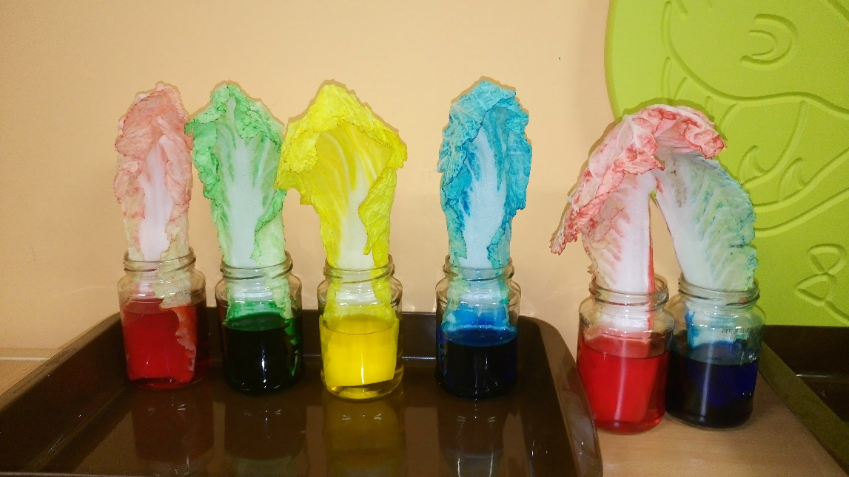

MATERIALS:
1. Chinese cabbage
2. Water
3. Food coloring
4. Clear glass jars, cups or small clear vase

Fill the glass with water.
Into each glass a few drops of food color.
Then place a separate cabbage leaf in each glass.
Children do the observation and assume what happens to the cabbage leaf because it lives in color water.
As the leaves of cabbage drink the water they will magically change color.

