LET’S EXPERIENCE AND LEARN
EXPERIMENT 2 (Weight of the liquids)

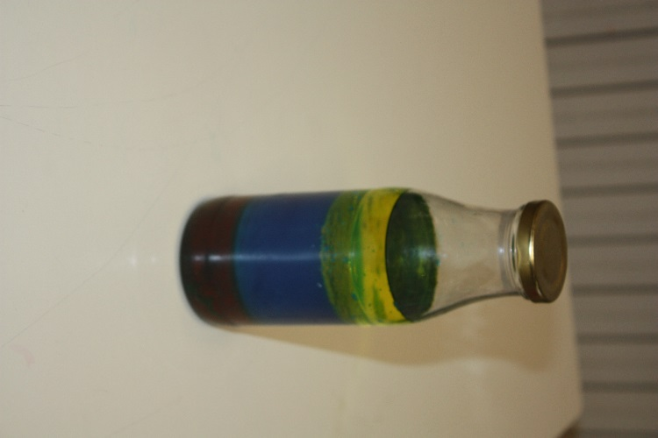
MATERIALS
1. WATER
2.COLOURING
3.ALCOHOL.
4.OIL
5.HONEY

WORk PLAN
- Firstly,put the honey in a container
- Later add alcohol in the contain.
- After that add colored water
- Finally, add the oil.
- .
- Finally, you can see that the stem that you have cut has different colours.

