LET’S EXPERIENCE AND LEARN
Experiment 2

Sea in bottle
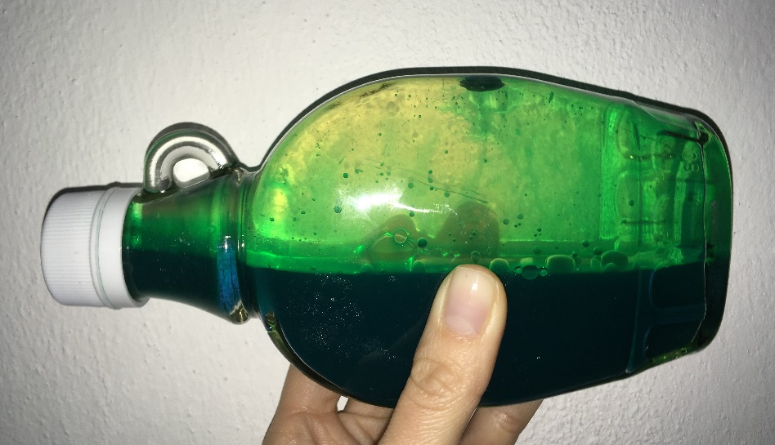
Materials:
- bottle
- water
- ink
- oil
- funnel
- cup

We add color ink to the water. We mix it properly. Using the funnel we carefully pour the water into the half of the bottle. We add oil to the edge of the bottle and close the bottle tightly.
We are watching "sea" waves and we are happy!

