LET’S EXPERIENCE AND LEARN

EXPERIMENT 6

Life Cycle Bean Plant

Bean plants provide a variety of experiences dealing with plants and the plant kingdom.

Material:
- 4 glass jars
- beans
- paper towels
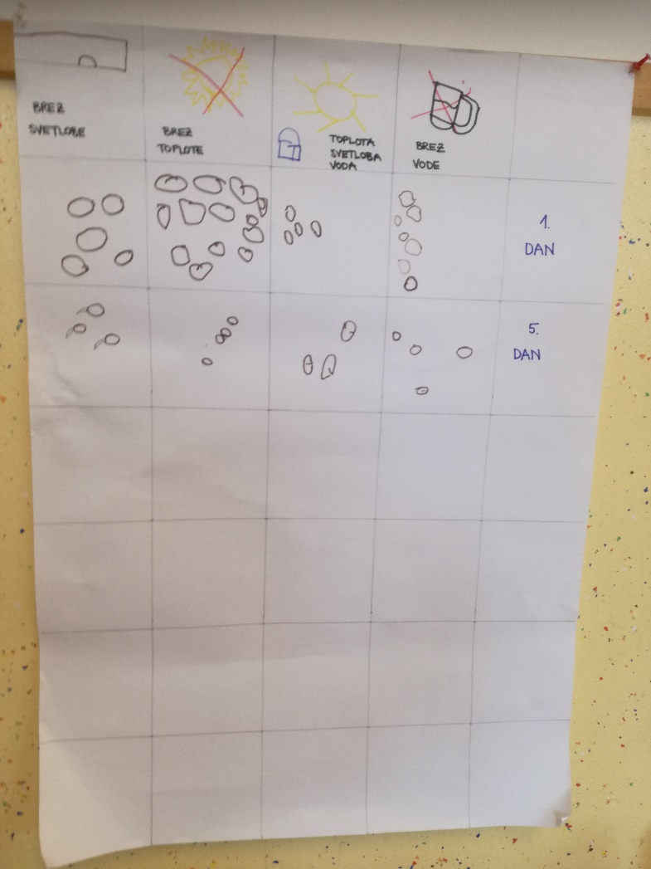

Tear paper towels into jars. Then drop a few beans in (seed).
In the first jar, make all the optimal condition for growth – water, light, heath.
Second jar – take away light (we putted a jar in a cupboard, closet.
Third jar – take away heat – we put it on a window shelf.
4tzh jar take away water.

Observe how the plant is growing.

