LET’S EXPERIENCE AND LEARN
EXPERIMENT 2 (Colored flowers)
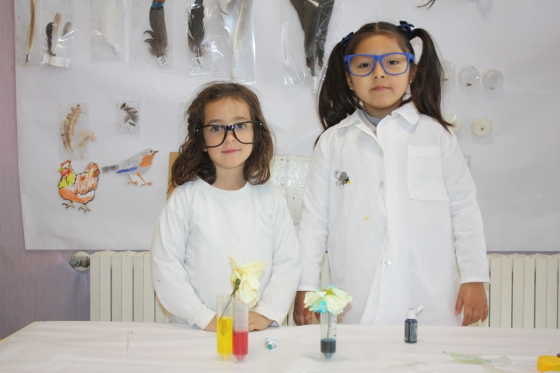

MATERIALS
1. WATER
2.COLOURING
3.FLOWERS

WORL PLAN
- Put water with colorant.
- Put the flowers inside the water.
- Cut the stem of a flower.
- Finally, you can see that the stem that you have cut has different colours.

