LET’S EXPERIENCE AND LEARN
Experiment 4

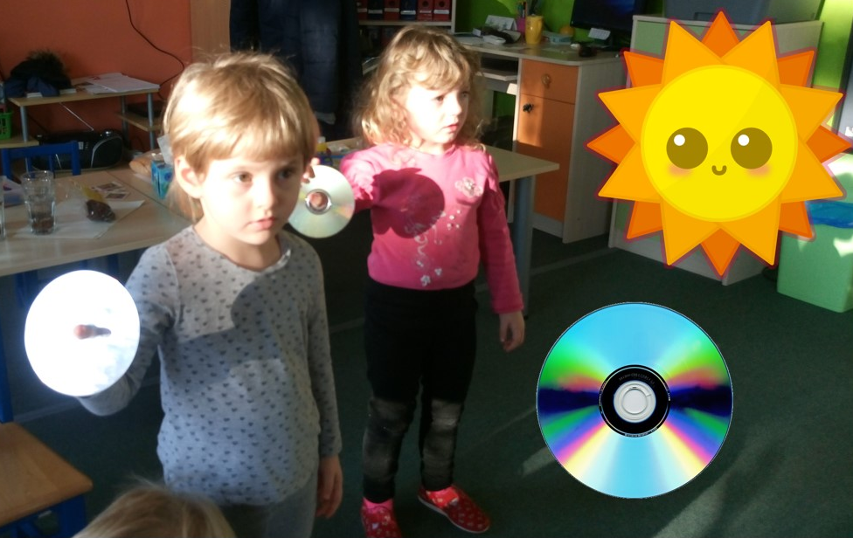

MATERIALS:
1. Blank or old CD
2. Sunny day

1. Find an area in school or outdoors to do the activity. You’ll want to be able to access sunlight with your CD and have an area in the shade to reflect the sunlight (If you don’t have a blank wall, you can use a piece of white poster board.)
2. Use the shiny side of the CD to reflect the sunlight onto your poster board or blank wall and notice the rainbow. What does it look like? Notice the shape and colors. What happens when you change the angle of the CD?
Have fun!

