LET’S EXPERIENCE AND LEARN
Experiment 3

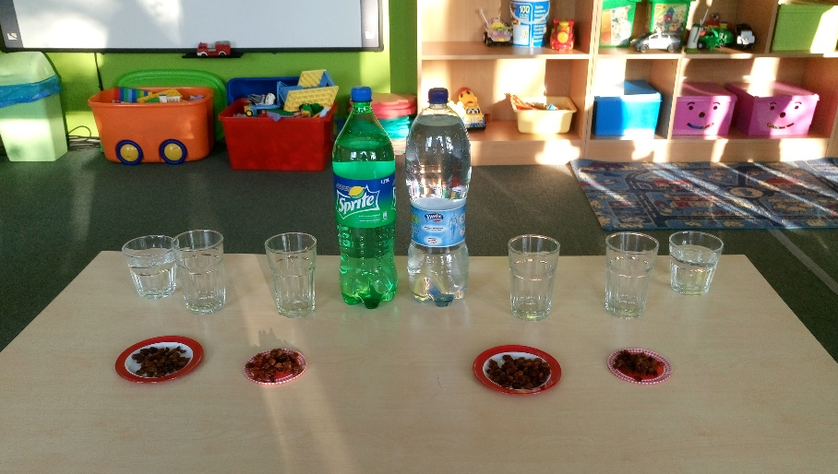

MATERIALS:
1. A box of raisins
2. A tall, clear glass or plastic cup
3. Well-carbonated soda (tonic water, club soda, and Sprite all work well)

Fill the glass with soda.
Drop 10-15 raisins into the soda.
Focus all of your attention on those raisins. Are they moving? Yes! They’re floating, they’re bobbing up and down, they’re dancing!

Have fun!

