LET’S EXPERIENCE AND LEARN

EXPERIMENT 1 AIR
MATERIALS
- BALLOON
- HAIR DRYER
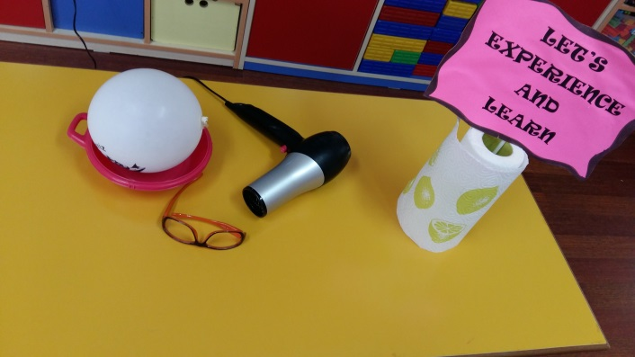

WORL PLAN
- The balloon is inflated
- Hair dryer opens
- The balloon is given hot air.
- Balloon flight observed.
- It is understood that the air moves.

