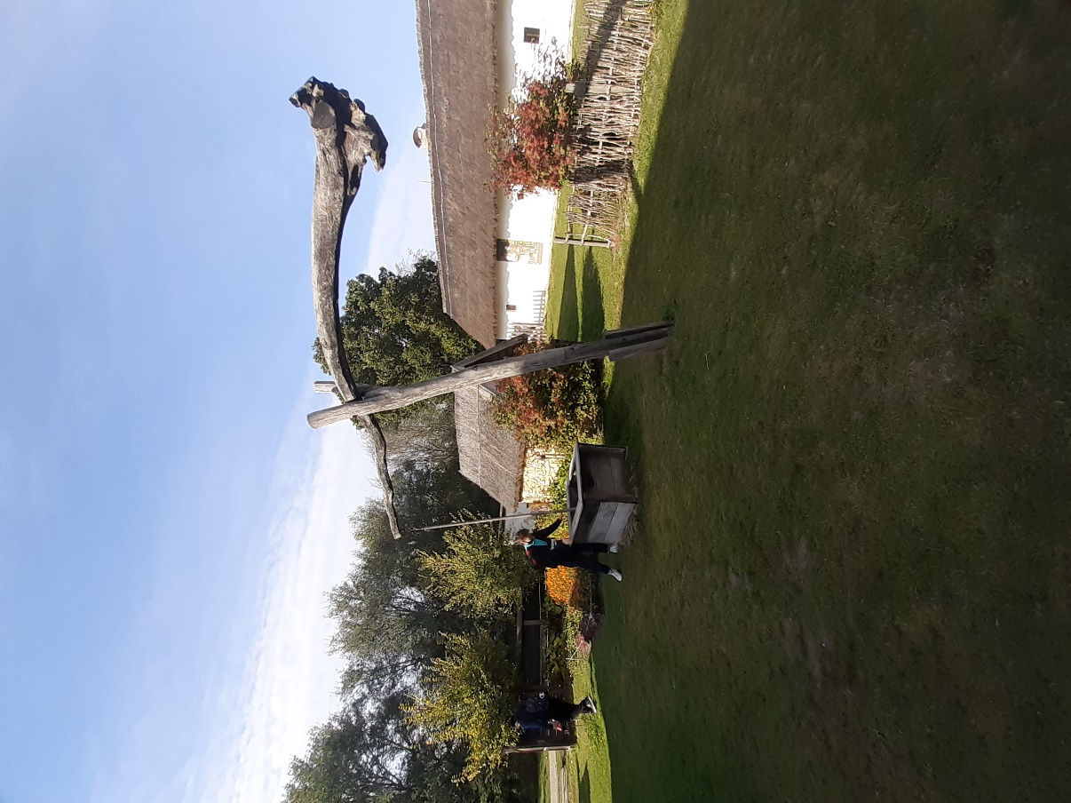

Here we see a shadoof, which functioned as a pump in the 19-20th century and even nowadays in particular areas of Hungary. This machine allowed people to pull up water from deep in the ground just like a well, but it was built easier. It used the weight on one side of the poll to pull up the water on the other side.

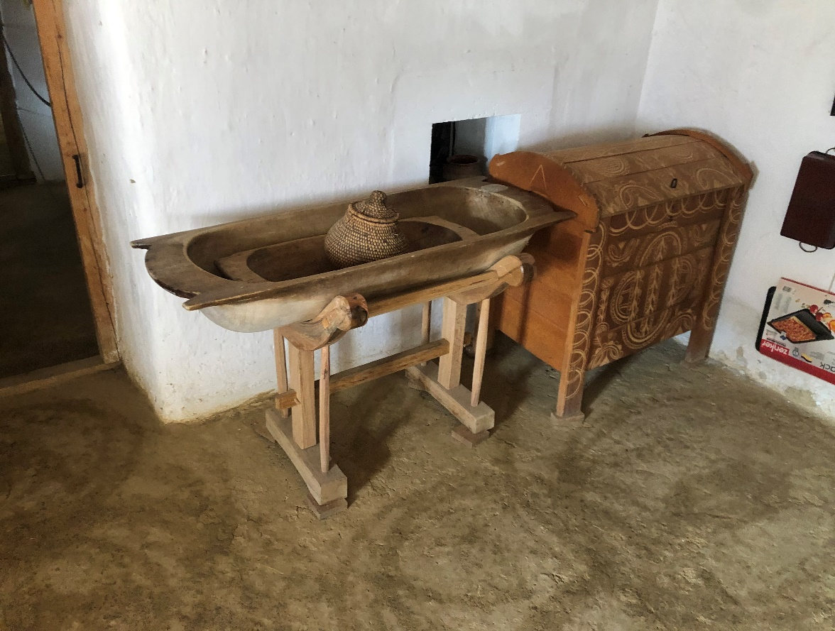

This wooden hollow was used by the lady of the house in the process of making bread. A carving like this could store bread mass for a family which could be enough for up to 3 weeks. They also raised and kneaded the raw bread in here.

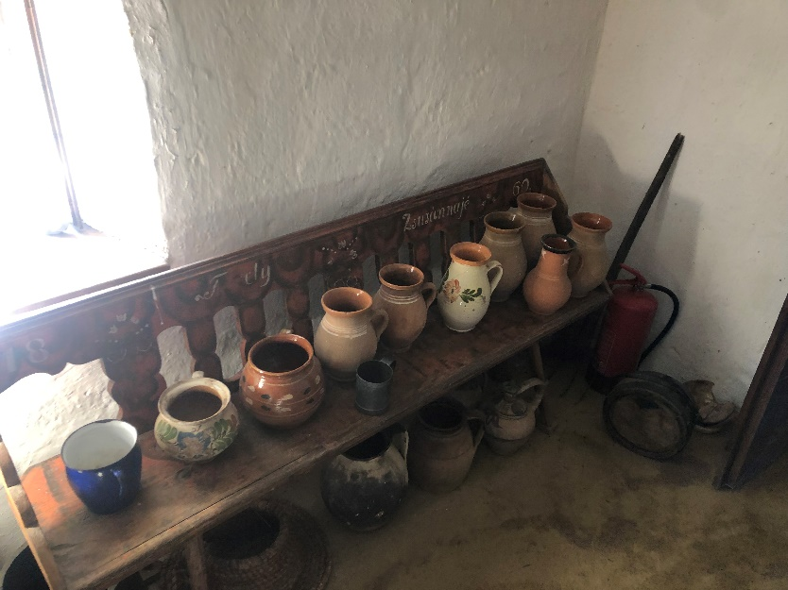

These potteries were made out of clay by the potter. This profession was greatly needed at the time due to the lack of plastic and porcelain. This meant that these clay jars were the primary storing facilities back then.

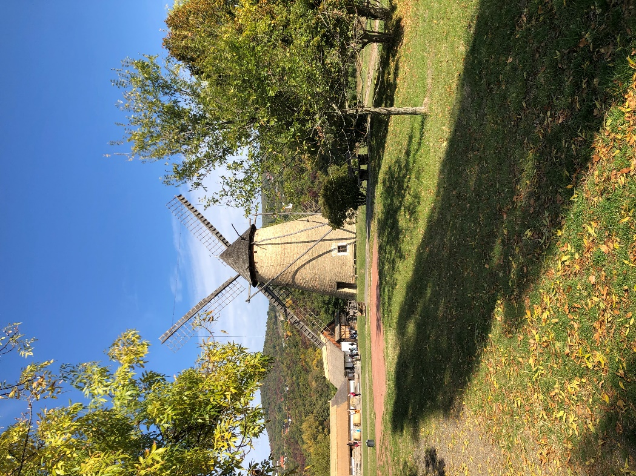

Windmill  
In the 19th century the most common food was bakery, and this explains why the windmill took a crucial part in the villages’ life. One windmill supplied several village with ground grain. These (big boys) structures operated till the engine based grinding started to spread in the countryside

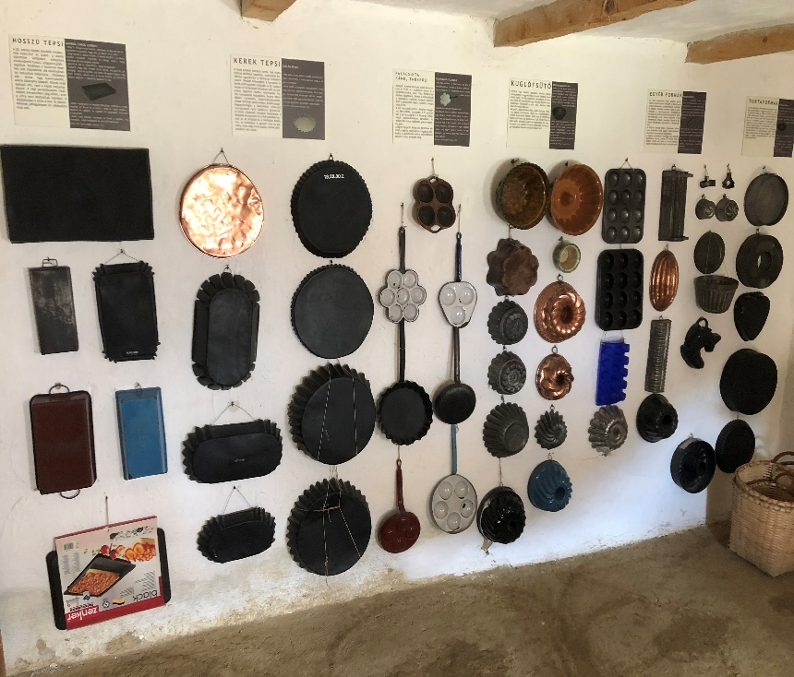

Pans   
In the picture we can see many kinds of roasting dishes and cake moulds. In the countryside, there was several traditional cake and potcake recipes what they liked to bake, especially for holidays.

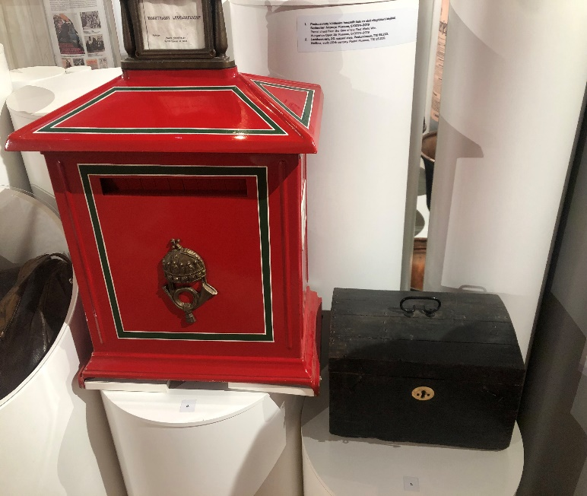

Mailbox  
These mailboxes were the primary communication “devices” until the thelephone. Extensive post network helped to get the mails to the addresse as soon as possible. And the transportation of these messages, gave work to thousands of people across the country.