Most jobs in the past were done by men, but women at home had to do various jobs as well.
This included cooking, sewing and looking after the kids. These are some tools that were used in the kitchen.
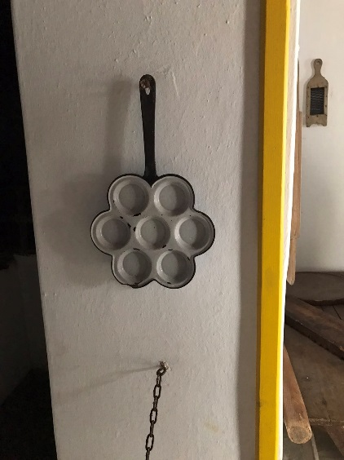

A special pan used for cooking a savory dish, somewhat like a pancake. It was mainly eaten by women and children. (Men ate bread instead)

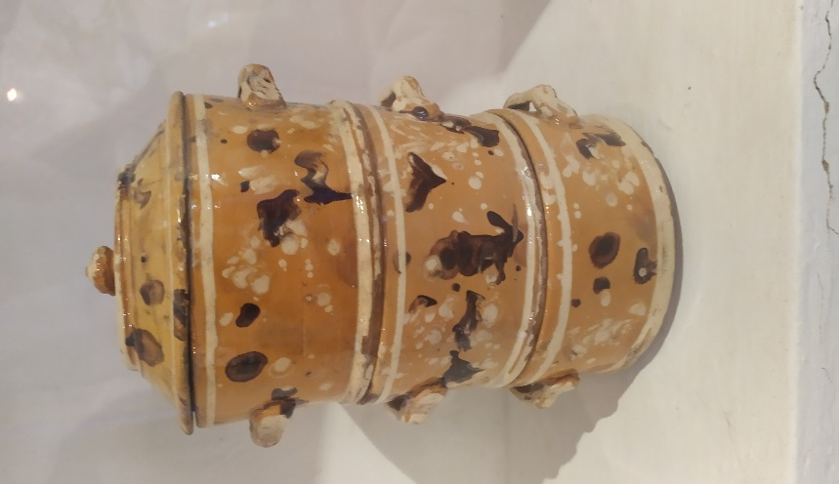

The komabowl, a special food-carrier. A beautiful work of pottery made for new mothers who had just given birth.

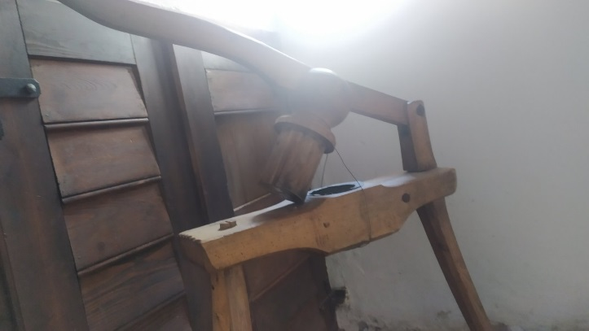
In this picture you can see a potato masher.
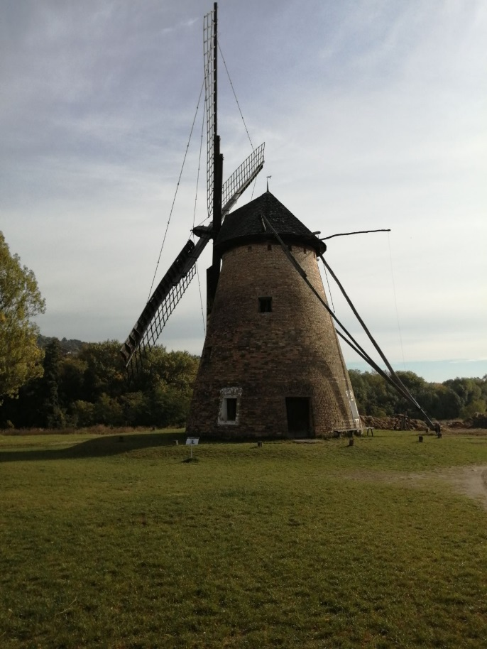
Back in the days men mostly worked as blacksmiths, kept animals and worked at the mill.
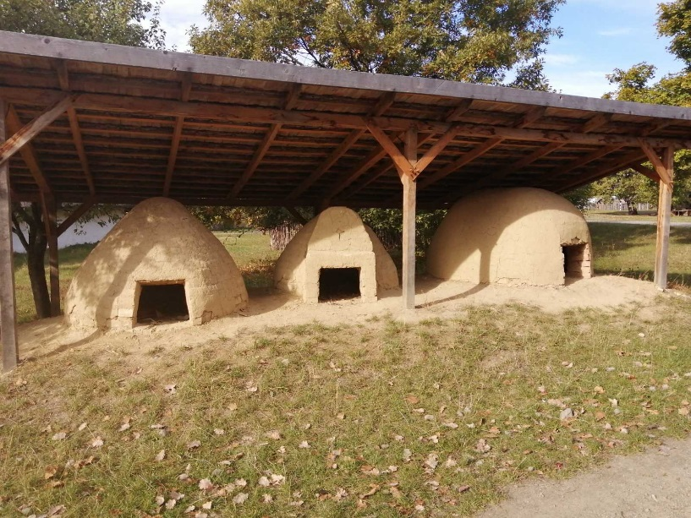
(Hungary was one of the biggest grain producers for Europe throughout the history)

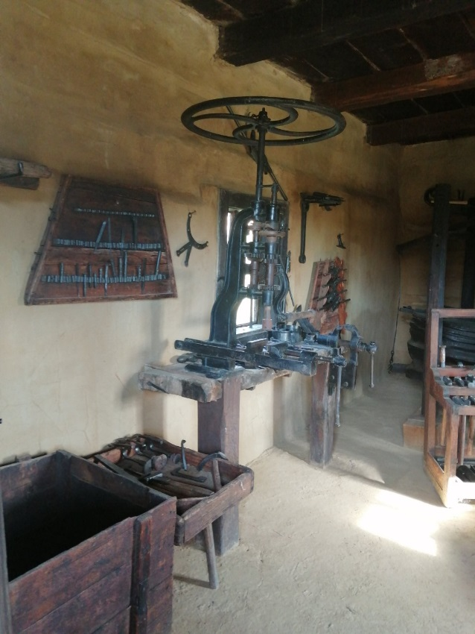

In the past candle-making was a traditional job. In the skanzen we also got the opportunity to get to know the process of how candles were made. We had to dip a string into wax and then water, we had to repeat this motion for many times. (approximately 50 times)
