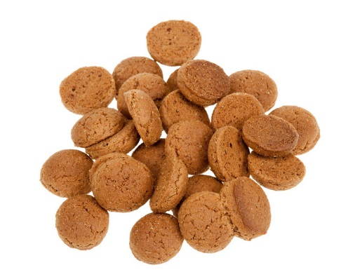
Recipe Peppernuts
Ingredients
- 40 gram margarine
- 50 gram brown bastard sugar
- 1 teaspoon speculaas spices
- 100 gram self-raising flower
- 2 spoons milk
oven 170 degrees
±20 minutes

Step 1:
Put all ingredients in a bowl.
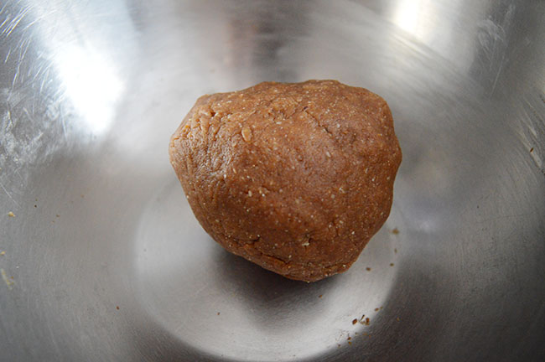
Step 2:

Mix the ingredients and make a dough.
Step 3:
Make little balls from the dough and put them on a baking tray.
Step 4:
Put them in an oven, 170 degrees in ±20 minutes.
The peppernuts are ready now!

