Improving internationalisation policy during the IMPACT-project

- Fill in internationalisation scale
- Assess your level
- Set up a plan to improve the level of internationalisation in your school
- Use the PDCA format
- Think short and long term

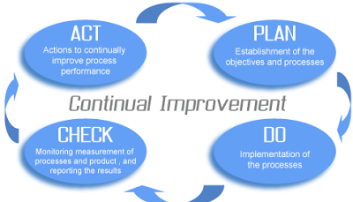

Plan:
Short term:
. Keep active in the ERASMUS + IMPACT Project throughout the next two years
. Keep pupils of the 4th grade active (9 year-old pupils)
. Include the 3rd grade (8/9 year-old pupils) and the 6th grade (11/12 year-old pupils) in the project
. Keep using the CLIL methodology in English classes
. Schedule a monthly meeting with primary school teachers to develop internationalisation
. Make internationalisation more visible at school

Long term:
. Add an international goal in the next school Educative Project (2019-2021)
e.g.: Primary school teachers must participate in (at least) an international program/ project/ activity each year

Do:
Short term:
- Exchange videos with our project partners (Mini Projects)
- Write and send letters/ postcards to our project partners (Mini Projects)
- Connec/ interact with partner schools via etwinning
- Reactiviteathe European Club and nominate a school coordinator
- Implement international activities:
. European Day of Languages
. Create a big board in the students’ room (so that everyone at school can see it)with:
. a world map locating all the international partners
. posters with greetings in different languages
. Post all the intrnational activities in the school official webpage and in the school facebok page
. Translate the school weekly menu into English
. Identify the diferent parts of the school in English (Office/ teachers’ room/ Canteen...)

Long term:
- When writing down the new school Educative Project (which lasts for 3 years), add a goal related to internationalisation and check, each year, if the goal is beeing fulfilled
- Continue with all the short term goals/ activities even afeter this ERASMUS+ Impact project is finished

Check (Next TTW):
Internationalisation scale (Next TTW)
Other:

Act (Next TTW):

