

Improving internationalisation policy during the IMPACT-project

1. Fill in internationalisation scale
2. Assess your level
3. Set up a plan to improve the level of internationalisation in your school
4. Use the PDCA format
5. Think short and long term

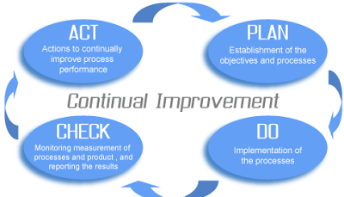

**Plan:**

**Short term:**

* Create a internationalisation group of teachers in our school (pending).
* We want to do a country project through the whole school in grade 4 until grade 6.
* To install skype.

**Long term:**

* One E-Twinning project one project in grade 1 until 3.
* When buying materials have Europe in your mind.

**Do:**

**Short term:**

* Create an internationalisation group of teachers in our school. They communicated with the other teachers about internationalisation plans or projects.
* To make the teachers enthusiastic about internationalisation we want to do a country project in our school. Every group is working on a different country. We want to do the project for two weeks and we want to show the results to the parents after the 2 weeks.
* Install Skype on the devices at our school.

**Long term:**

* We want to do a project In grade 1 until 3 with e-twinning. The teachers who have already work with it are helping the colleagues from grade 1 until 3.

Check:

Internationalisation scale (Next TTW)

Other:

Act:

