Improving internationalisation policy during the IMPACT-project

- Fill in internationalisation scale
- Assess your level
- Set up a plan to improve the level of internationalisation in your school
- Use the PDCA format
- Think short and long term

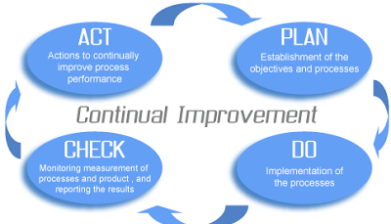

Plan:
Short term:
. provide activities with international partners to the students.

Long term:
. share with the group colleagues the observed practices of the Netherlands;
. motivate teachers to implement some practices observed in the Netherlands.

Do:
Short term:
. make videoconferences with students from European countries;
. share videos in youtube, twinspace and in facebook MYM- Eu Consigo! page.

Long term:
. Share international experiences with my colleagues at school in each monthly meeting;
. Invite teachers at my school to participate in European projects.

Check:
Internationalisation scale (Next TTW)
Other:

Act:

