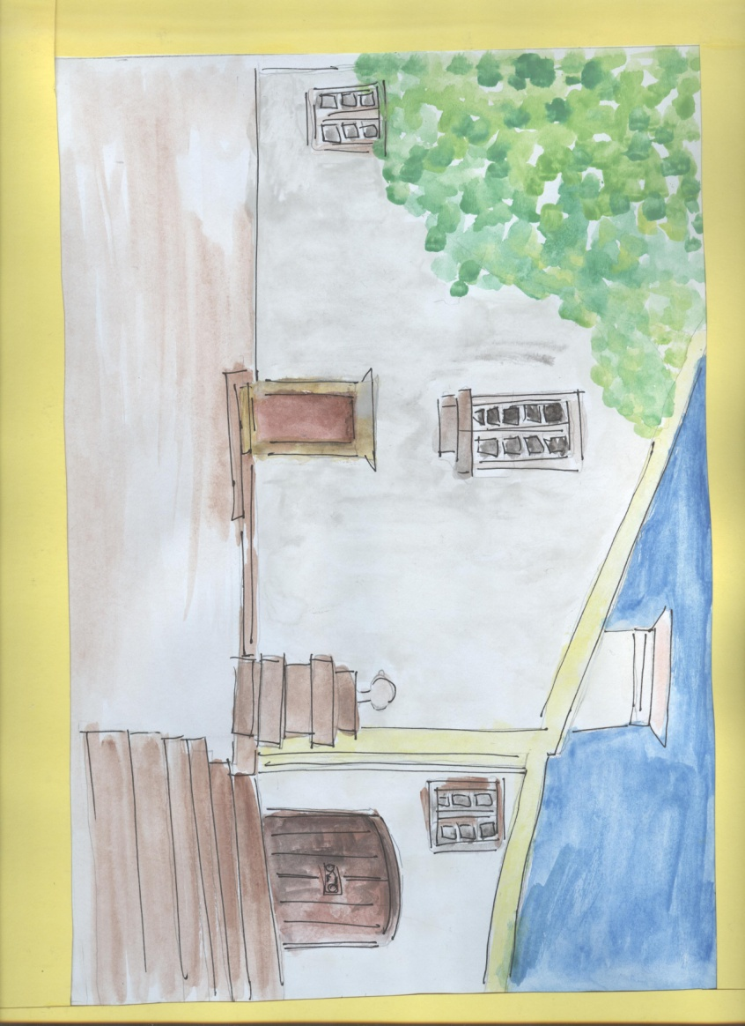

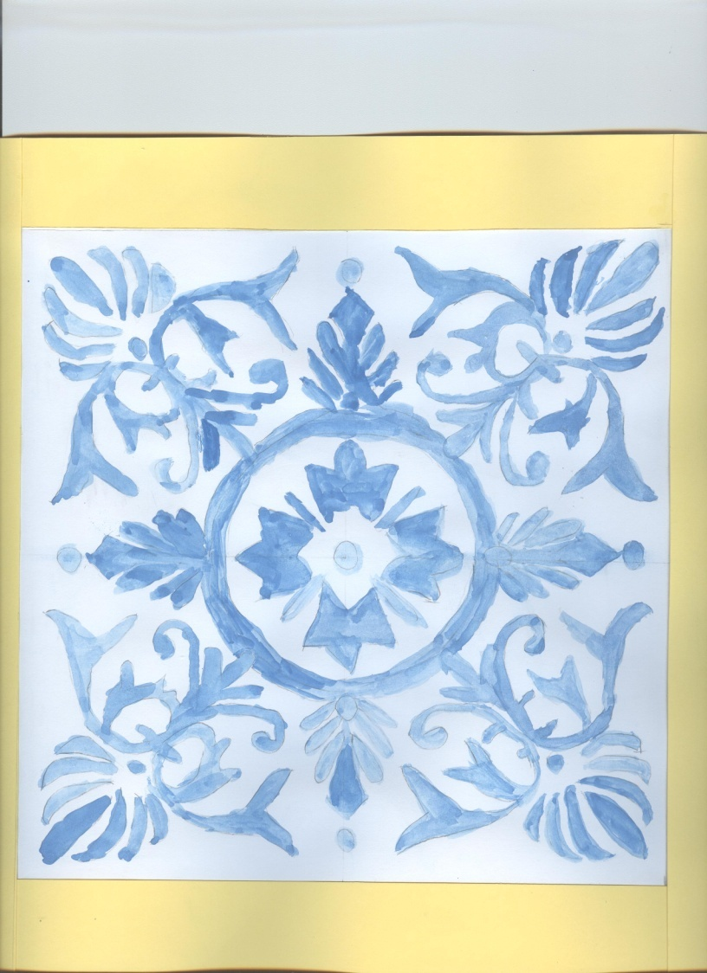

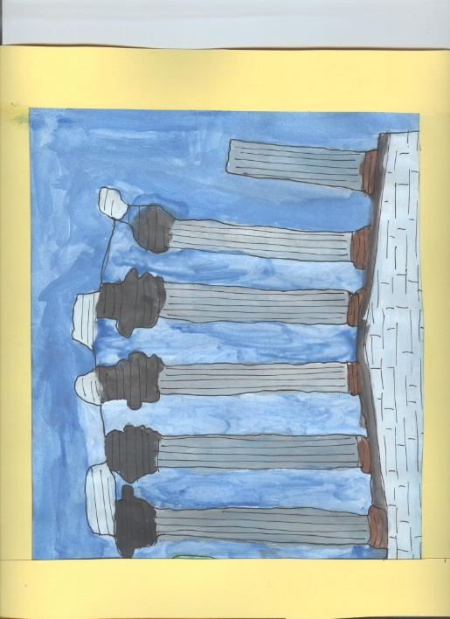

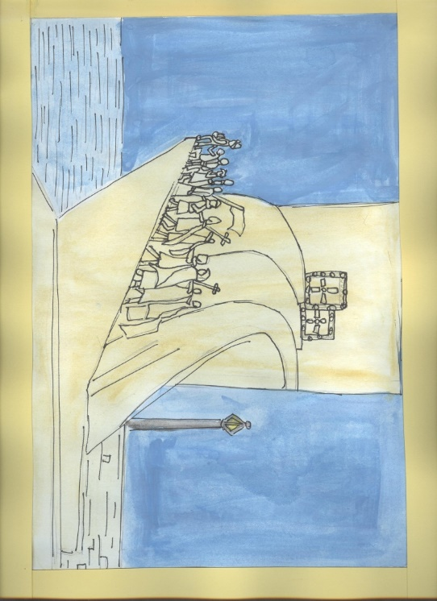

**Agrupamento de Escolas José Régio**



**Portalegre - Portugal**

***Erasmus+ Impact***

[](https://www.google.st/url?sa=i&rct=j&q=&esrc=s&source=images&cd=&cad=rja&uact=8&ved=2ahUKEwiC46-d8sTfAhUuxYUKHY1-CFIQjRx6BAgBEAU&url=https://en.wikipedia.org/wiki/Flag_of_Turkey&psig=AOvVaw38fonVphxxOTW4omRsqT-G&ust=1546167844592091)

**Portugal**

**Turquia**

**Catalunha**

|  |  |  |
| --- | --- | --- |
| https://static.lojaodosesportes.com.br/product_images/1500x1500/o/249/italia__86582.png |  | https://http2.mlstatic.com/blusinha-viscolycra-com-strass-bandeira-da-holanda-D_NQ_NP_15862-MLB20108960716_062014-F.jpg |
|  |  |  |

**Holanda**

**Itália**

