TAJIKISTAN

CENTRAL ASIA

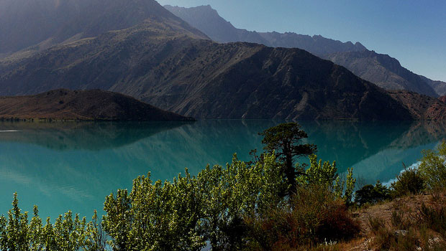

One of the most interesting country of Central Asia is Tajikistan.
The word Tajikistan means the “Land of the Tajiks”, where Tajiks refers to Iranian-speaking peoples as used in the medieval times.
Tajikistan is a place to visit because has got beautiful and untouched mountain scenery.

Here we can see some interesting places of Tajikistan:

Alauddin Lakes
Du-Oba
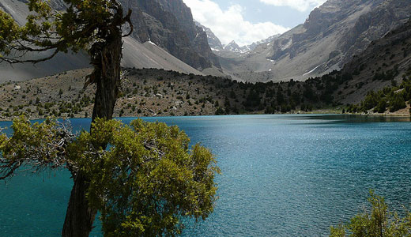
The Alauddin Lakes is a beautiful lake with clear and cool waters, perfect for swimming and relaxing.

Ayni Opera & Ballet Theatre
Dushanbe
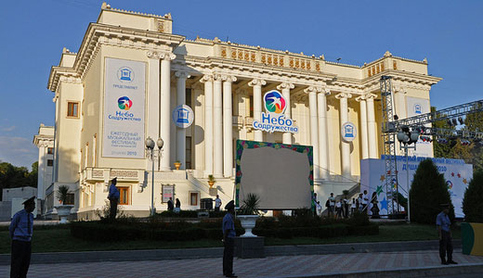
The Ayni Opera & Ballet Theatre is a theater for opera and classical music concerts.

Fann Mountains

Tajikistan
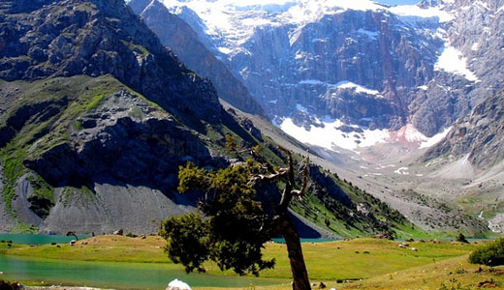
The Fann Mountains is one of the largest tourist attraction in Tajikistan.
Here you can enjoy mountaineering, rock climbing, and ice climbing.
The scenery is great.

Gissar Fort

Hisor
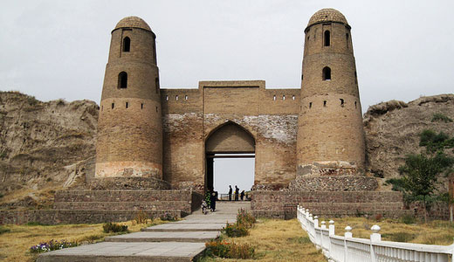
Gissar Fort is a picturesque fortress in the Gissar Valley.
The fort is located in a hill with a great Islamic-style arched doorway and two round towers.

Iskanderkul Lake
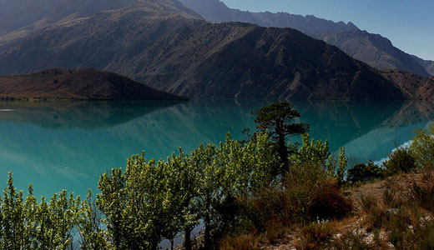
The Iskanderkul Lake is surrounded by the Fann Mountains and is one of the most beautiful places to visit in Tajikistan.
It is 2.5 km long and 1 km across and sits at an altitude of 2,255m above sea level, with turquoise and calm water.

Kulikalon Lakes

Kulikalon
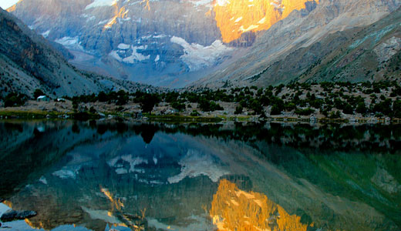
The Kulikalon Lakes is a group of three glacial lakes, in the Zeravshan Mountains of south-western Sughd Province.
The lakes are famous for their ability to shimmer with all colors of a rainbow which provides a breathtaking sight.

National Museum of Antiquities of Tajikistan

5, Academic Rajobov St, Dushanbe
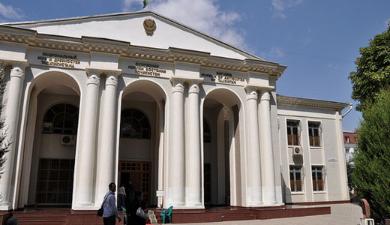
The National Museum of Antiquities of Tajikistan is the best museum in the country.
It is a museum that focuses on the Greco-Bactrian sites of Takht-i-Sangin.
One of the museum’s highlight is the 13 m-long sleeping Buddha of Adjina-Tepe (Witches Hill), which was excavated in 1966.

Pamir Highway

Dushanbe
-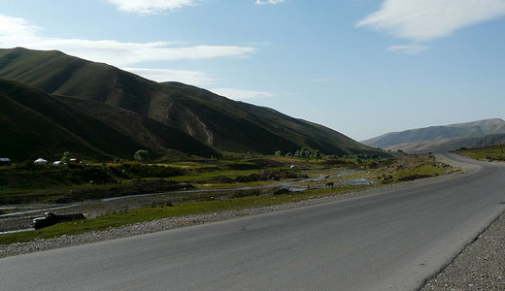
The Pamir Highway was built by Soviet military engineers between 1931 and 1934.
It was made to facilitate troops, transport and provision.
The highway offers an amazing scenery.

Rudaki Park

Rudaki Ave, Dushanbe
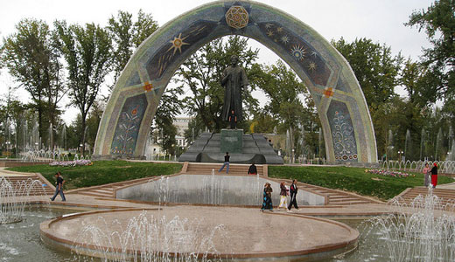
The Rudaki Park is a great recreational area, in Dushanbe, It has views of the new palace and an interesting statue of Rudaki, at the center.

Seven Lakes
Marguzor
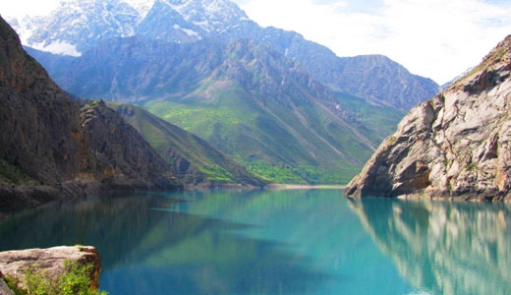
The names of the lakes are: Mijgon at 1640 m, Saya at 1740 m, Gushor, Nofin at 1820 m, Hurdak at 1870 m, Marguzor at 2140 m and Hazorchashma.
The Seven lakes is a popular place for tourists to visit, becouse the lakes have very different waters that change their colors from turquoise to green, blue and even black, depending on sun position in the sky.

Timur-Dara Lake

Tajikistan
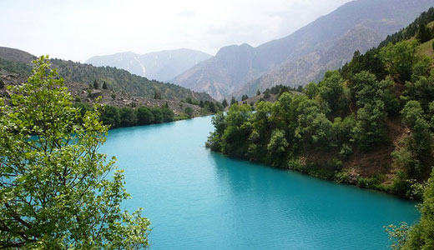
The Timur-Dara Lake is situated among wooded slopes.
The lake has bright-blue waters and has coarse-grained granite sand which make an excellent beach.

