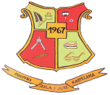
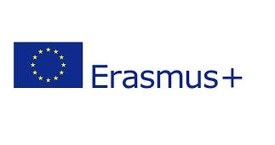
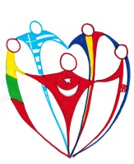

WE ARE THE WORLD WE ARE THE CHILDREN
2014-1-LT01-KA201-000522_4
4th LEARNING/TEACHING/TRAINING ACTIVITY
Zagreb – Croatia
March 2016

TITLE: Pedagogical workshop – Children heroes
DATE: 18th March 2016
PLACE: Primary school Jure Kaštelan, Zagreb
TEACHER: Patricija Lipnjak

OBJECTIVES:
- to define who is a hero and find out whether children can be heroes
- to define the necessary actions children should take when they find themselves in dangerous situations, or when aiding someone else
- to point out to students that we are all connected, and that we can only solve our problems by working together, helping each other and communicating

DESCRIPTION:
Students are divided in groups. Each group will receive a story about a hero, and under each story they will find a few questions that they will have to answer after reading. The workshop leader will discuss students' answers with them and ask them what words they could use to describe characters from the stories – heroes. After that, we will define together who is a hero, what makes a hero and how people become heroes. The last question – Can children be heroes? – will start the next activity “I can be a hero”.

