ORTHODOX EASTER IN GREECE

Easter is one of t he most important orthodox Christian celebration in Greece. In the eyes of the Greek Orthodox Church it is honor to commemorade the fact that Jesus died on the cross for our sins. For Greek people, they’re ready to celebrate. After weeks of careful fasting and prayer, they are eagyer to break the fast and finally eat foods that have been deprived for them. Since Easter is such n important holiday to the Greeks there are many traditions that have developed because of it. Here’s a summary of some of them prominent.
Attending church
Preparating for Pascha (Easter) begins at the start of Great Lent Orthodox Christians fast and pray regularly during the forty days of lent and also during Holy Week. For many Greeks the church service that takes place in the evening of Holy Saturday is the most important one. However in the church they’re all equally as important.

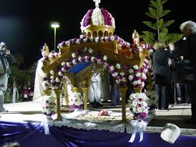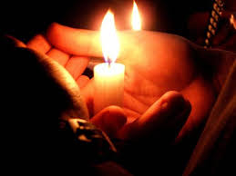

Holy Saturday Service
Just before midnight, the church goes completely dark. After midnight, the church lights up with candlelight as people light their tapers from their neighbor’s and begin chanting “Christos Anesti.” The traditional hymn is also sung. Translated, it means “Christ is risen from the dead. By his death, he has trampled down death. To those in the tomb he gave eternal life.” This hymn is sung for several weeks after Easter during the church services.
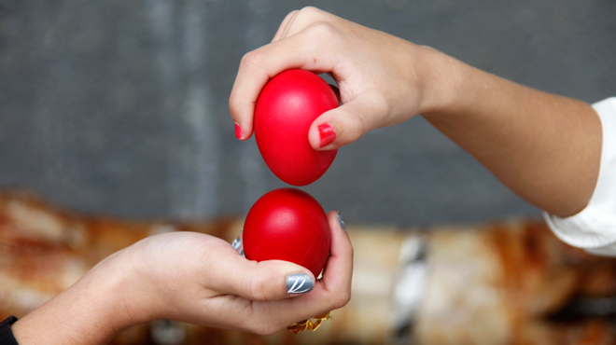

Easter Sunday’s Early Meal
Greeks are eager to break the fast they engaged in during Holy Lent as soon as possible, so many of them eat a meal right after they get home from the Holy Saturday church service. The traditional dish to serve during this meal is magaritsa, which is a soup that is made from the organs of the lamb that will be prepared for the main feast. However, some families opt to eat their big Easter dinner during this time. If that is the case, they’ll likely still serve magaritsa.
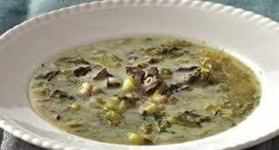

Red Dyed Easter Eggs
In Greek Easter dinner all the eggs are dyed red and there are no pastel colored eggs at the table at all. This is because the egg has come to symbolize Christ’s tomb, which has been stained red with His blood. This is a visual reminder of the fact that He died on the cross for our sins.

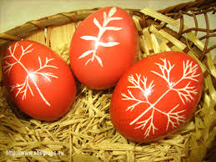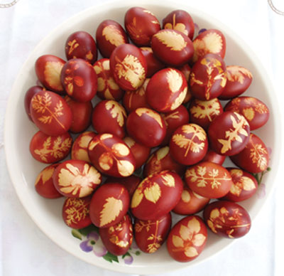

Roasted Lamb
Roasted lamb is the traditional meat of choice on the Greek Easter table. It is normally seasoned and prepared on a spit, or souvla. In regions of Greece where lamb isn’t readily available, goat is served instead. The reason why this is served is because according to the Apostle John, Jesus is the Lamb of God. He died on the cross as a sacrifice for our sins. Eating lamb honors this.
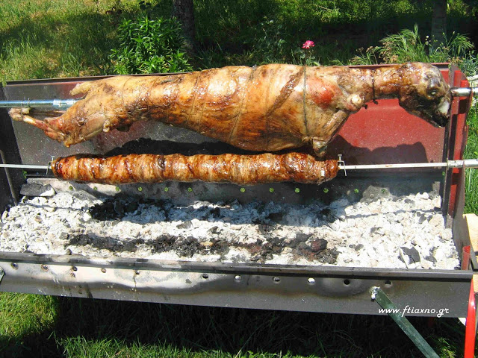

Tsoureki – Greek Easter Bread
Another dish that is present at the Greek Easter table is tsoureki, the traditional sweet bread. You’ll recognize this bread because it will likely have a red Easter egg baked right in the center. This bread contains several ingredients that were forbidden during Great Lent such as eggs, butter, and sugar. Some families take this one step further and use the traditional tsoureki dough to make small sweet rolls for the guest to enjoy.
