Name: ____________­­­­­____________

Date: __________ Group: _____

E-twinning project – 5th Grade



**DESIGN A LOGO**

Objective:

* Design a logo for the project in the template below.

**TRAILS AROUND EUROPE**

These are the countries that are taking part in the project:

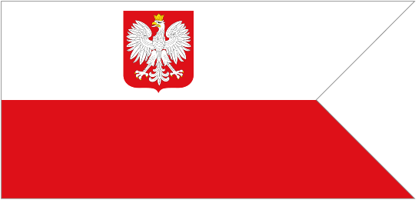

Greece UK Estonia Poland

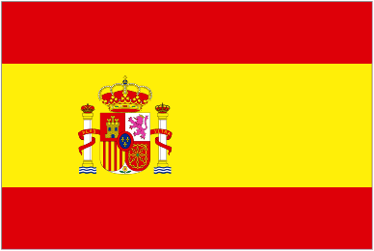

France Spain

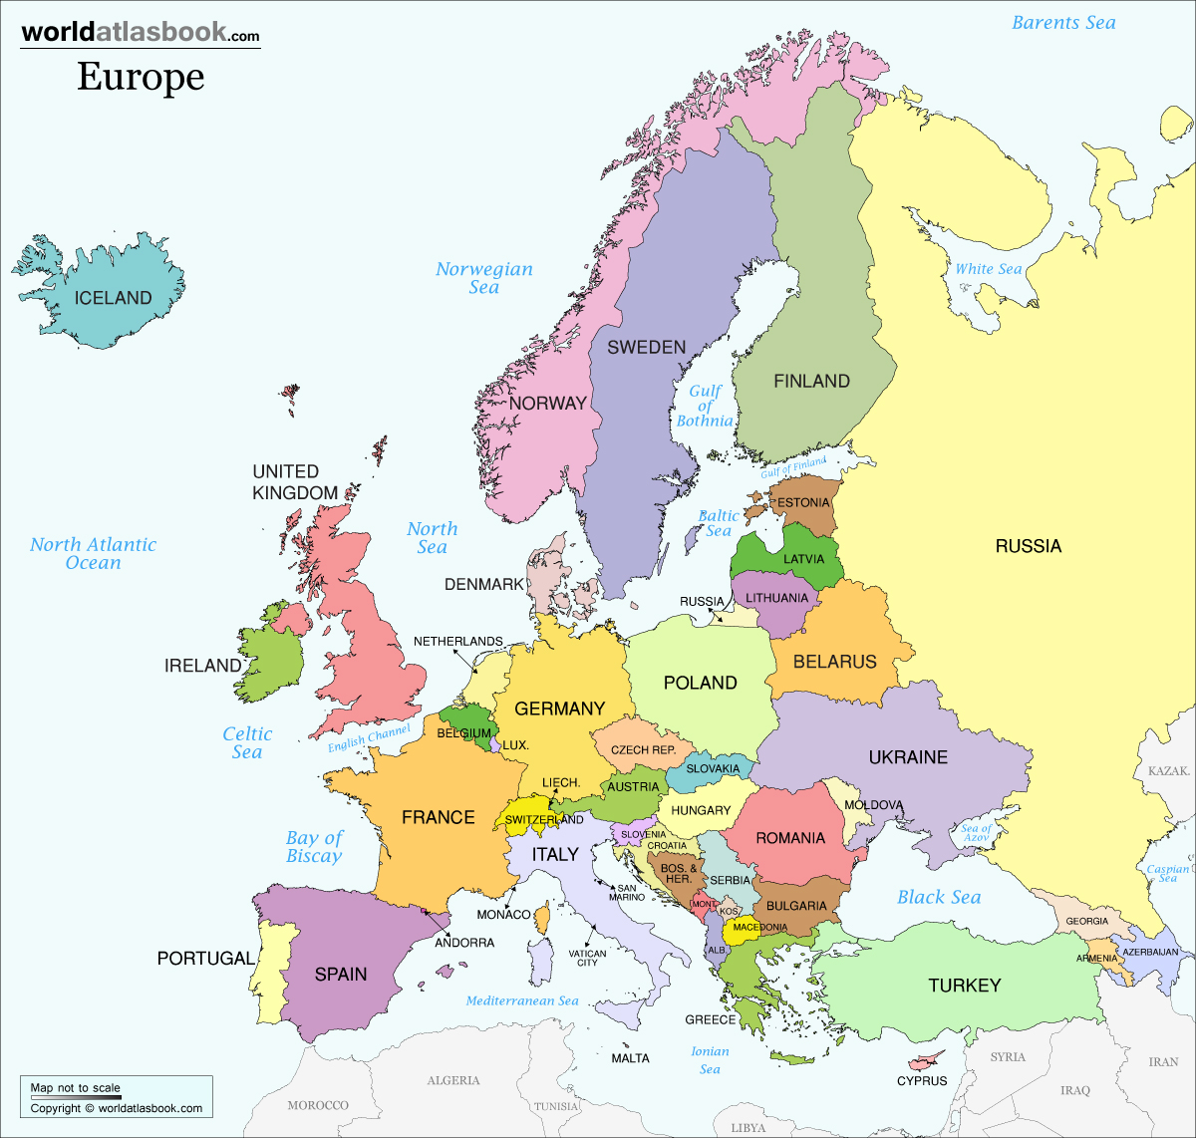

Name: ____________­­­­­____________

Date: __________ Group: _____

E-twinning project – 5th Grade



Design your own logo here