Kus Kus

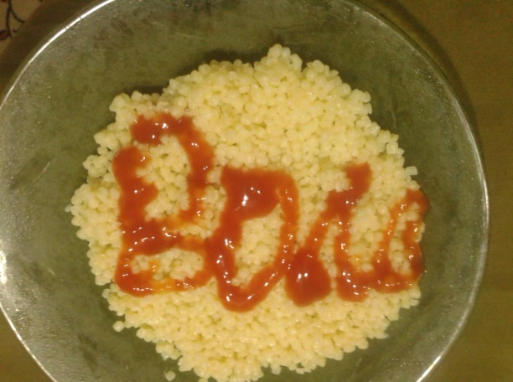
1 lb couscous
2-3 Tbsp extra virgin olive oil
2 medium carrots, cut into cubes
½ cup sweet peas
½ cup sweet corn
¼ cup parsley, finely chopped
1 Tbsp fresh mint, finely chopped (optional)

Cook couscous according to the directions over the package in salty water. Drain and stir in extra virgin olive oil.
Meanwhile, boil carrots and sweet peas in lightly salty water for about 2-3 minutes. Rinse under cold water and set aside to drain. Add the vegetables, parsley and mint into the couscous and mix. Serve either cold or warm.
What is the percentage of kus kus out of all the ingredients?
$$\frac{500}{775}=\frac{k}{100}⟹r=\frac{50000}{775}=65.51⟹k\%≈65\%$$

