TURKISH MANTI

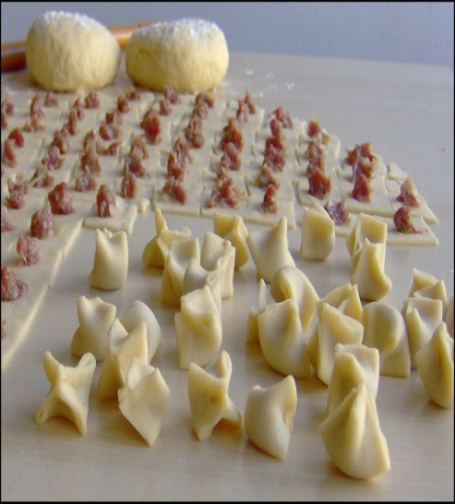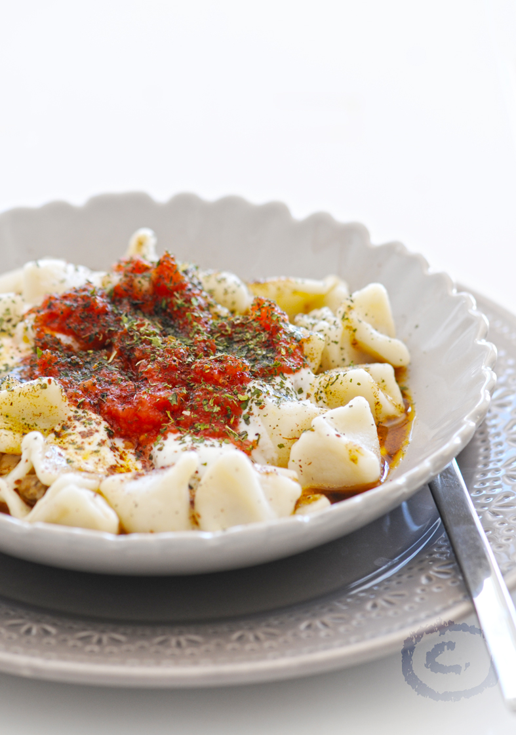
Author: Panning The Globe
Recipe type: Main Course
Cuisine: Turkish
Prep time: 3 hours
Cook time: 25 mins
Total time: 3 hours 25 mins
Serves: 6
Link: http://www.panningtheglobe.com/2013/11/05/turkish-manti/
Ingredients
- Dough
- 3 cups flour
- 2 large eggs
- ½ cup warm water
- ½ teaspoon salt
- Filling
- ¾ pound ground lamb (or beef)
- 1 small onion, grated or finely chopped (6-8 tablespoons)
- 4 tablespoons finely chopped parsley
- 1 teaspoon salt
- Yogurt Sauce
- 2 cups whole milk Greek yogurt
- 3 large cloves garlic, pressed
- ½ teaspoon Salt
- Caramelized tomato paste
- 1 6-ounce can tomato paste (organic is best)
- 4 tablespoons extra virgin olive oil
- 1 cup water
- 1 tablespoon ground Aleppo pepper (or substitute 1½ teaspoons sweet paprika plus ½ teaspoon crushed red pepper flakes)
- Brown butter sauce
- 3 tablespoons unsalted butter
- 3 tablespoons olive oil
- Kosher salt, to taste
- Spices for sprinkling on top
What is the percentage of potatoes out of all the ingredients?
$$\frac{450}{1935}=\frac{f}{100}⟹r=\frac{45000}{1935}⟹f=23.25⟹r\%=23\%$$
What is the percentage of vegetables out of all the ingredients?
$$\frac{750}{1935}=\frac{l}{100}⟹r=\frac{75000}{1935}⟹l\%=38\%$$
What is the percentage of spices out of all the ingredients?
$$\frac{20}{1935}=\frac{s}{100}⟹r=\frac{2000}{1935}⟹s\%=1\%$$

Instructions
- Make the Dough: Pour flour and salt into a pile on a work surface or large board. Make a well in the center of the flour and crack the eggs into it. Start with a fork, mixing the eggs and incorporating the flour. When the mixture is too thick for stirring with a fork, start using your hands to mix everything together, gradually adding the water, as you start to knead and press the dough. Knead dough for 8-10 minutes until you get a firm, smooth dough. Cover with a damp cloth and let it rest for 30 minutes.
- Prepare the filling: While the dough rests, combine lamb, onion, parsley and salt in a small bowl. Set aside.
- Prepare the yogurt sauce: Mix all ingredients in a small bowl. Store in the fridge. (Bring to room temp before serving)
- Fill Manti: preheat oven to 325ºF. Cut dough into fourths. (Work with one piece at a time, leaving others covered to prevent drying) Roll dough on floured surface, into a thin sheet, about 1/16 of an inch thick. Use a knife or a pizza cutter to cut into 1½-inch squares. (you can use the edge of a ruler as a guide) Add a small ball of meat - about the size of a chickpea - to the center of each square. Pull the four corners up around the meat and press the four side seams firmly together to seal. Set manti onto a baking sheet, lined with parchment paper. (you'll need two baking sheets) Repeat with the rest of the dough. You should have about 120 manti. Bake manti for 15 minutes, until it just starts to brown. At this point you can let the manti cool and store it in the fridge for up to a day or in the freezer for up to two weeks. Allow to come to room temp before continuing.
- Prepare the tomato sauce Cook oil and tomato paste in a small pot over medium low heat, stirring constantly, for about 7 minutes, until you get a deep rich color and oil is incorporated. Add Aleppo (or paprika and red pepper) and cook, stirring for 30 seconds longer. Remove from heat. Add water and whisk to combine. Set aside. (Reheat just before serving)
- Prepare butter sauce: Melt butter in a small saucepan over medium heat. Whisk constantly for 1-3 minutes, until you see little brown flecks appear. Remove from heat. Add olive oil. Set aside.
- Bring a large pot of salted water to a boil. Add manti and cook at a gentle boil 10-12 minutes, until tender. Drain. Return manti to its cooking pot. Pour butter sauce over and toss to coat, reheating gently, if need be. Season with salt, to taste. Divide manti between 6 bowls. Spoon on the tomato sauce and yogurt. drizzle on any extra butter sauce. Sprinkle with spices. Enjoy!

