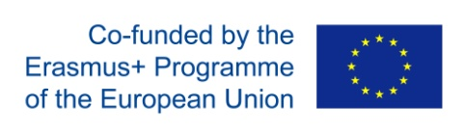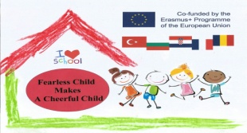 **WORKING TOGETHER**

**(PARENT INVOLVEMENT)**

**ACTIVITY NAME AND SUMMARY**

**WE'RE PREPARING FOR THE EASTER HOLIDAYS**

Because we are close to Easter, we invited our parents to join us in an activity that included song, dance and practical activity.

Parents and children, together, made a basket in which they put the eggs they had received as gifts.

**BENEFITS OF THIS ACTIVITY**

Within the limits of their understanding, preschoolers of the lowest preschool class have received some information about the Easter holiday, the symbolism of the dyed eggs and other traditions and customs specific to this holiday.

The presence of parents encouraged the children to prove that they can dance and sing, and parents were pleased to observe the evolution of their children.

Happiness in the eyes of the children at the end of their activity when they put their egg in the basket gave much joy to their parents.

The time spent together was appreciated by both children and parents.

**PHOTOS OF ACTIVITY(2 PHOTO)**

