
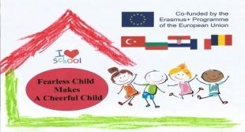
WORKING TOGETHER (PARENT INVOLVEMENT)
PLAYING TOGETHER

This project is a preventive system set up at the nursery school to enable families to get to know each other in a different way with the school and its partners, to build bonds and to feel sufficiently confident and recognized to finally dare to take a real place in the school. It is a bridge between the family and the school.
The game is placed under the sign of the principle of pleasure and it promotes the psycho-affective development of the child; It allows him to distance himself from unpleasant events and also to compensate for his unfulfilled needs: anger, aggression, domination ...)

Parents are welcomed at school once a week from November to June on Tuesday morning from 8:45 am to 9:45 am , in the School Library by the school psychologist and specialist teachers.
Various rules games, symbolic games, cooperative games are offered so that parents play with their children and other parents and children and members of the RASED *. Coffee and cakes are offered to make this moment of exchanges friendly.
Audience: Families and children: November, December, January, GS (5th years) / February, March, April, MS (4 years) / May, June, PS (3 years).
* Ritual of beginning of session : game to say “ hello”: to introduce oneslf, to give one's first name. Presentation of the different session times and rules : do not damage the material / do not hurt / musical signal to arrange and regroup.
* Time of the game: Each one settles in small groups around the tables of games. * Tidy up.
* Time to regroup: Reading a story, song, listening to traditional music to mark the end of the session .

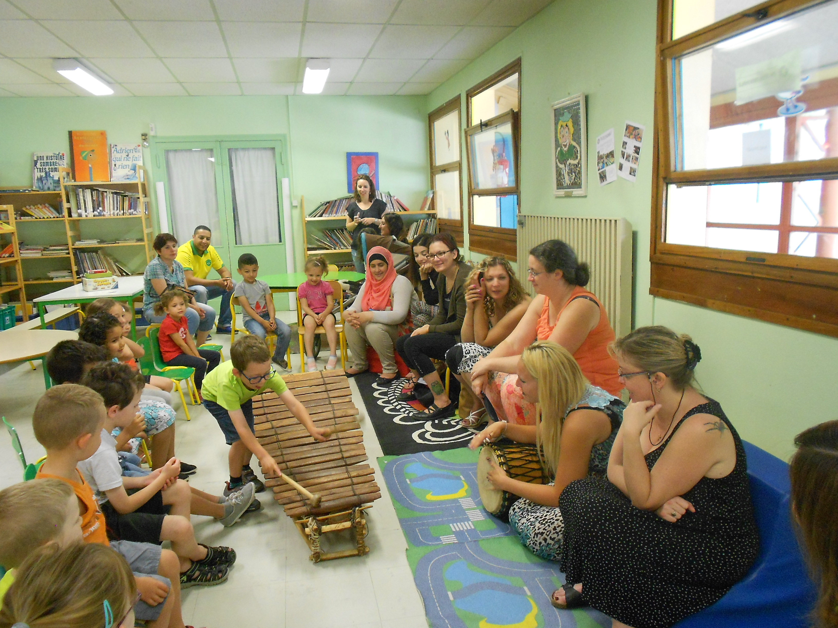
BENEFITS OF THIS ACTIVITY :
This activity has a significant effect on the school climate, one can see: an improvement in the well-being of children ./. Decreased violence, disciplinary problems, inequalities in education. /.A decline in absenteeism and dropping out of school.
* RASED: psychologist and specialized teachers.

