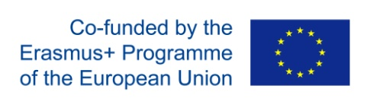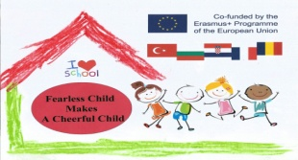 **WORKING TOGETHER**

**(PARENT INVOLVEMENT)**

**LONG TERM COOPERATION**

* **Adaptation period in the group**
* **Workshop within the Comenius project regarding the water pollution**
* **Landscaping the back yard and gardening**
* **Visting the grandparents farm ( with 2 groups )**
* **Celebrations with the family at their home**
* **Different workshops during the years**

**BENEFITS OF THIS ACTIVITY**

**The whole family has been involved in the early age education throughout the years which resulted in a great cooperation between preschool and family and many great moments together. Mother was in a group during the adaptation period ( both of her kids ) which went pretty smooth and the girl was well adapted into the group. In the years to come she held a workshop within the Comenius project regarding the water polution and father was actively engaged in landscaping of our back yard and gardening. In that way parents actively participate in the process and show their children the importance of education and cooperation with school. With their second child ( boy ) the adaptation wasn`t necessary because by that time he got to know both of the teachers as well as the group. Our cooperation still continues through different activities such as visits to the grandparents farm with the whole group and also visit to the parents home for special occasions ( children birthdays and barbecues organized by the family Jurišević ).**

