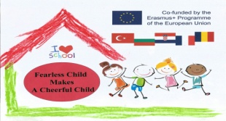 **HAPPY SCHOOL DAYS IN KINDERGARTEN NO. 37**

**SUMMARY OF THE ACTIVITY**

At the end of May, Kindergarten with extended program no. 37 organized the "Happy school day" activity. For a week, I've been doing all kinds of activities meant to make those days great for both children and parents and teachers.

Thus, we organized concerts and dance performances in the kindergarten and in its yard. Having kindergarten classes in the Waldorf educational alternative, we had finger games and social games among children, parents and teachers from our kindergarten, to the joy of everyone. The children guided by the teachers prepared a theater show, "Goat with three little kids", which was performed in the kindergarten.

The week ended with a theater show, "The little goat with three kids ", held in the Great Garden. The play was interpreted by teachers in collaboration with pupils from the pedagogical high school (who are future teachers), to the joy of the children.

Starting from the title of the project, "Fearless Child Makes a Cheerful Child", parents had the opportunity to see once again that the process of children adaptation was successful.

**PHOTOS (4 PHOTOS)**

