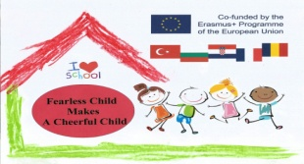 **WORKING TOGETHER**

**(PARENT INVOLVEMENT)**

**ACTIVITY NAME AND SUMMARY**

**“Workshop of Christmas decorations with children and their parents”**

**First we involved parents in collecting different natural materials suitable for making Christmas decorations, like pine cones, different seeds, husks etc. After parents arrived on workshop, children sang few Christmas songs and together with their parents started making decorations. Each decoration was originally made and was result of kids and parents creativity, there was no pattern. We use them to decorate our kindergarten`s Christmas tree.**

**PHOTOS OF ACTIVITY(2 PHOTO)**

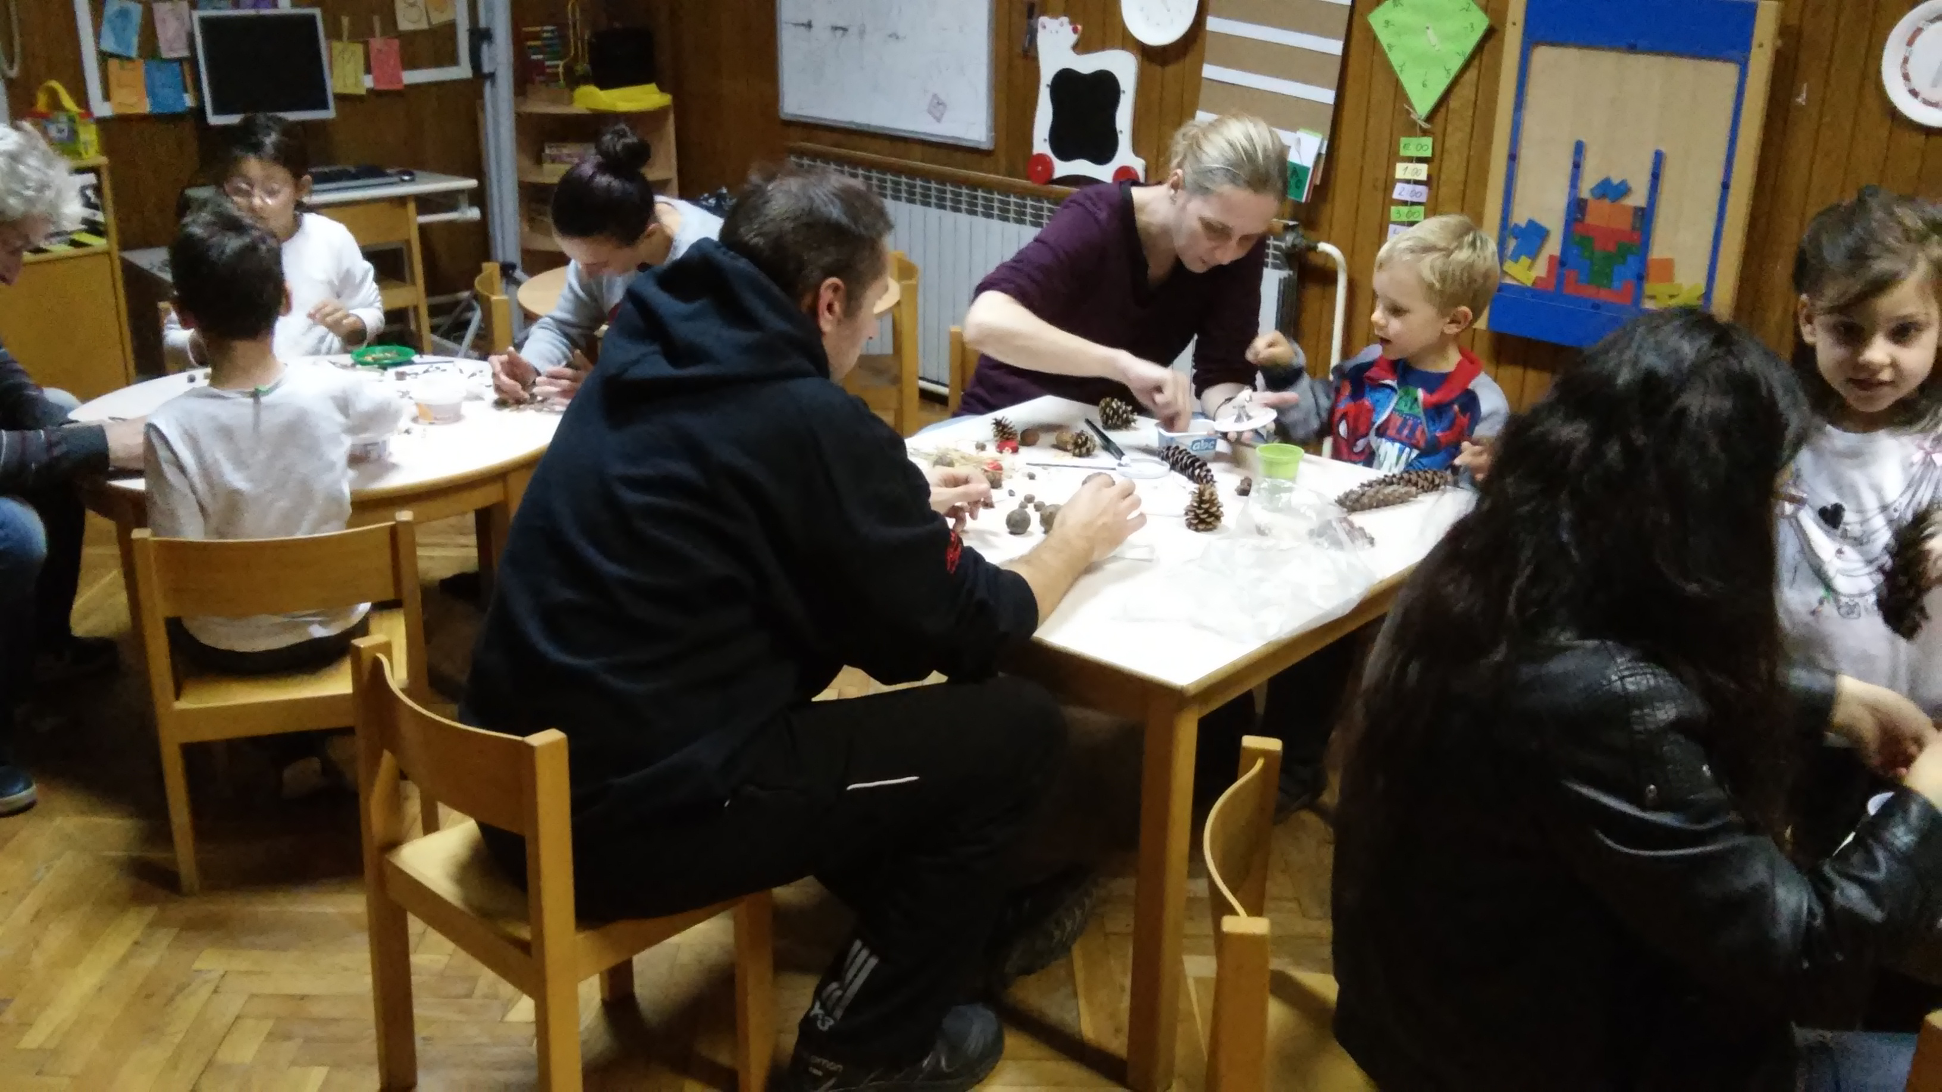

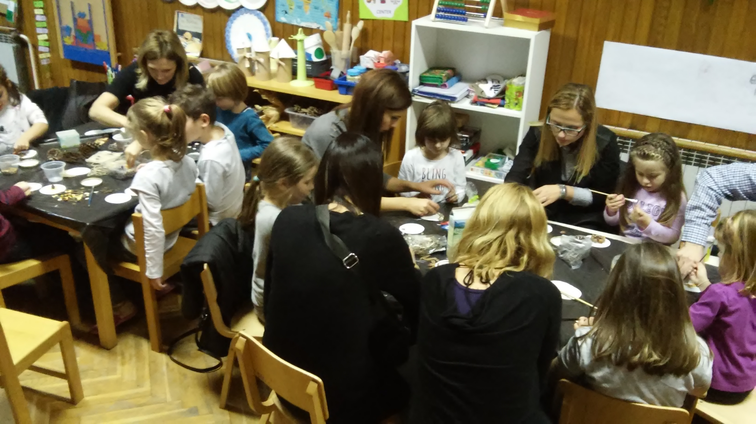

**BENEFITS OF THIS ACTIVITY**

**Children had experience of holiday at kindergarten as well, which helped in making pleasant experience and positive attitude towards kindergarten. Parents involvement in activity increased children`s motivation and sense of importance of what they are doing. Activity was stimulating for developing kid`s creativity, artistic expression and fine motor skills.**