Math and Art- The Magic of Fibonacci Sequence
Integrating Math in History Classes

Aim:
To understand the importance of Fibonacci spiral / the golden ratio through art
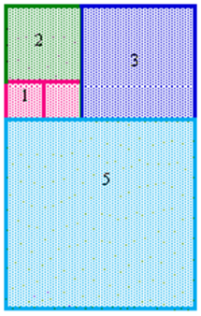
Activities in class:
- Introduction:
Introducing Fibonacci sequence of numbers and spiral

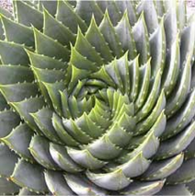
- Presenting examples of Fibonacci spiral and sequence in Nature

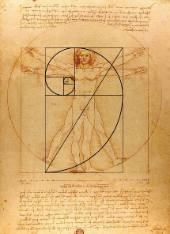
- Main activities:
  - Explaining the implementation of the golden ratio in the Renaissance masterpieces

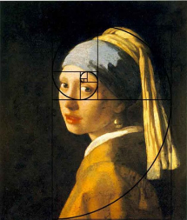
  - Working on and discovering Fibonacci spiral/ golden ratio in the baroque art

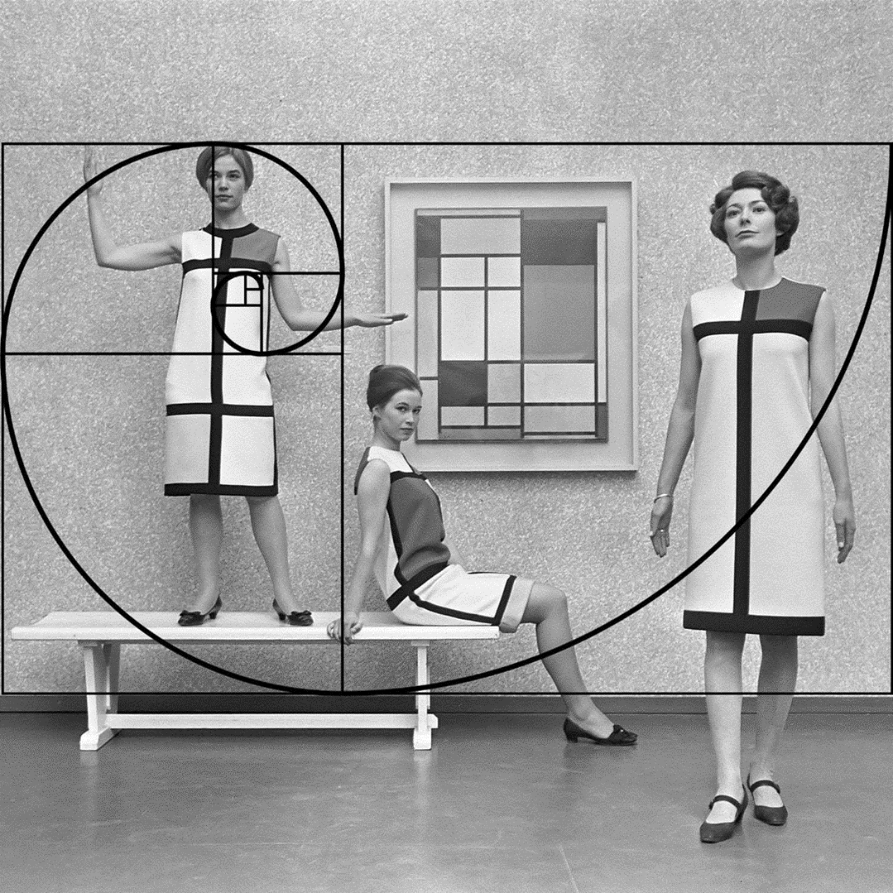
- Linking past and present: Exploring Fibonacci influence in contemporary art and fashion

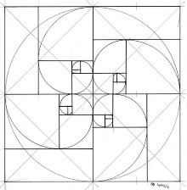
- Follow up activity:
Hands on Fibonacci art creations - do it yourself!

